**Completed Lab:**

Lab 1,2,3,6

SQL Server

Azure cache for Redis

Key Vault

Kubernetes

**Lab 1:**

Exercise 1

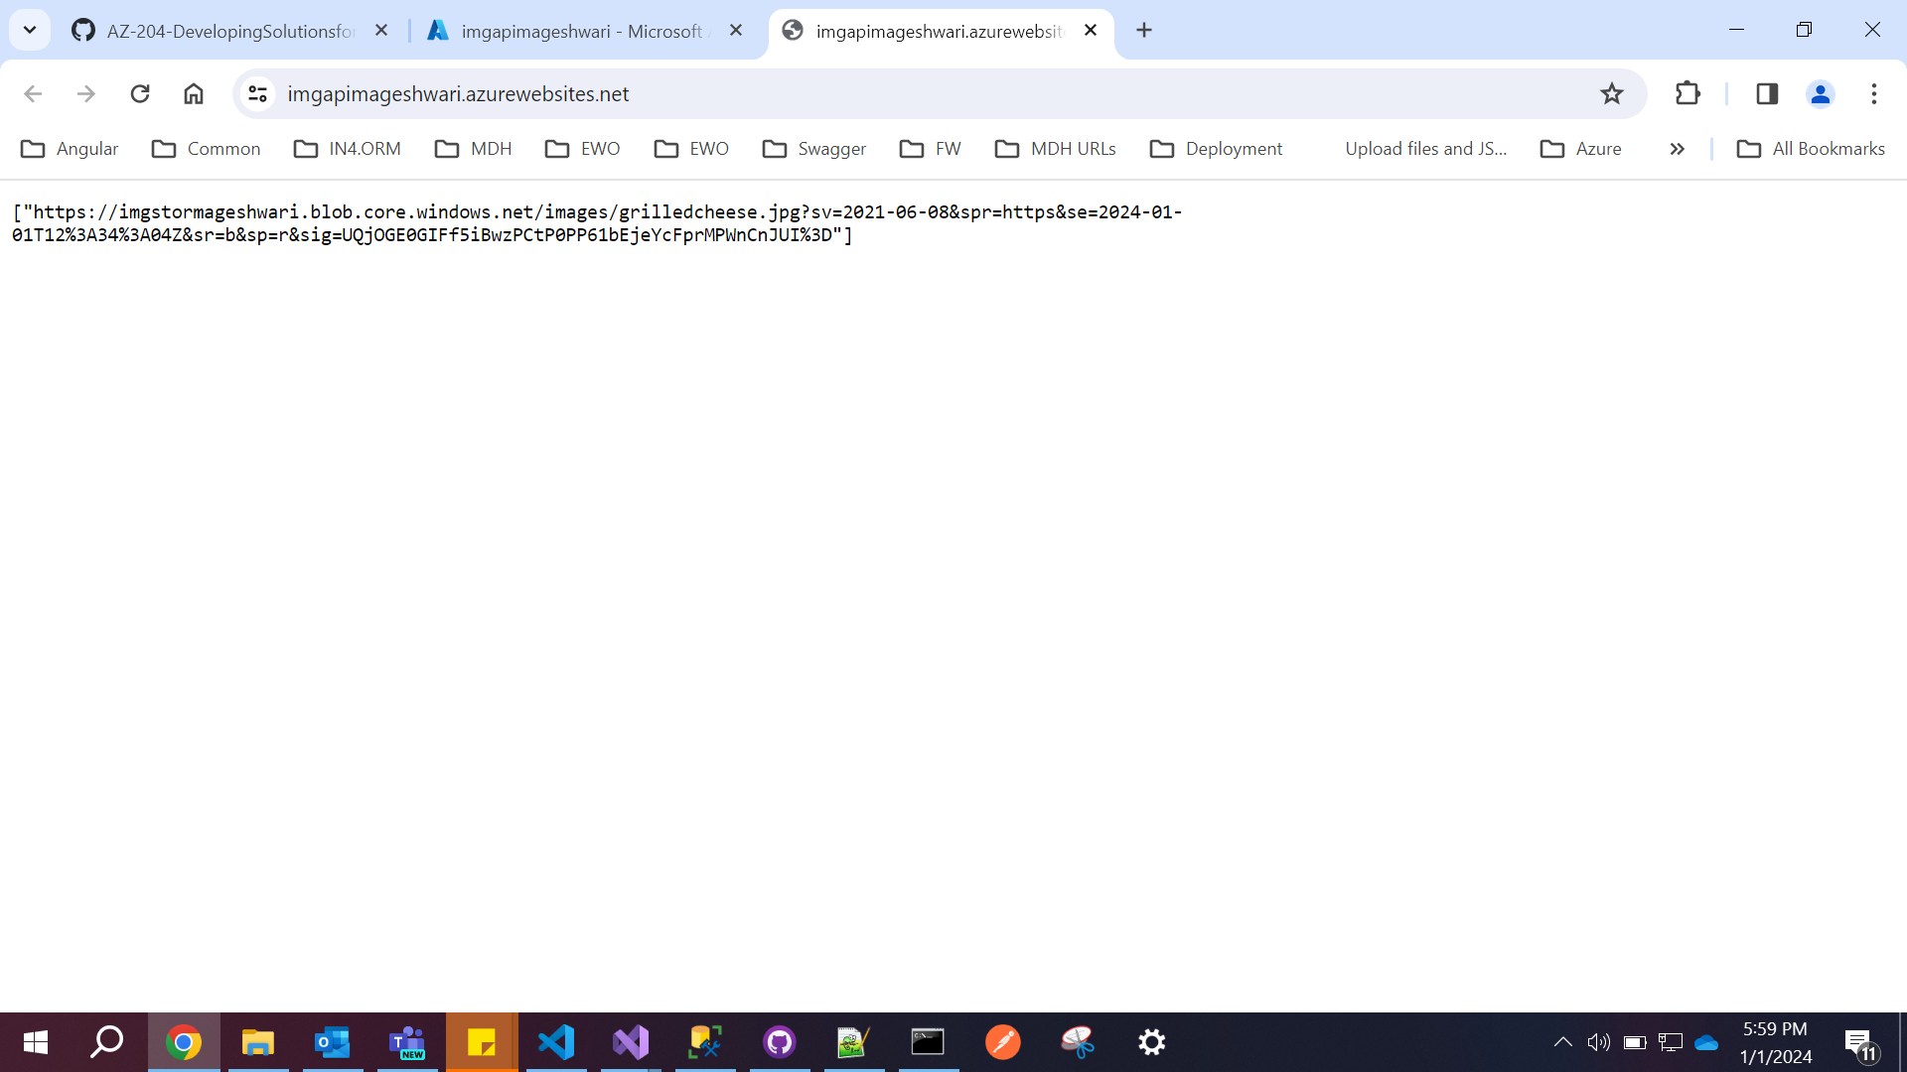

Exercise 2

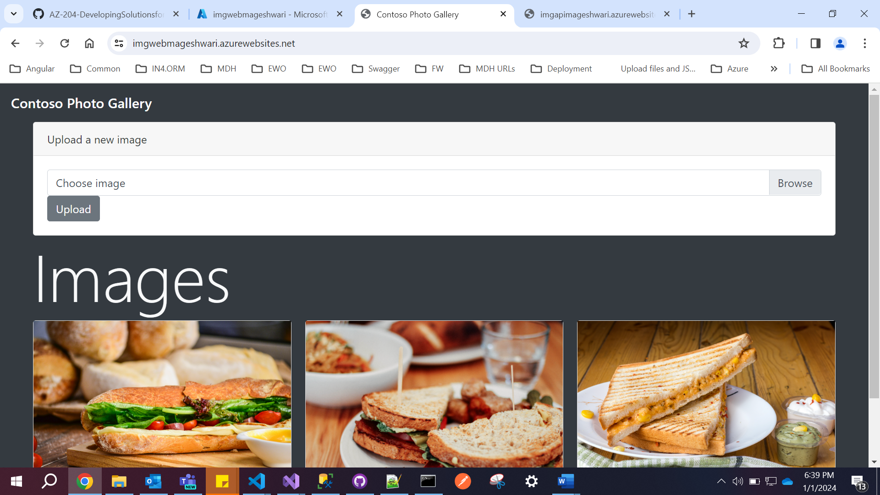

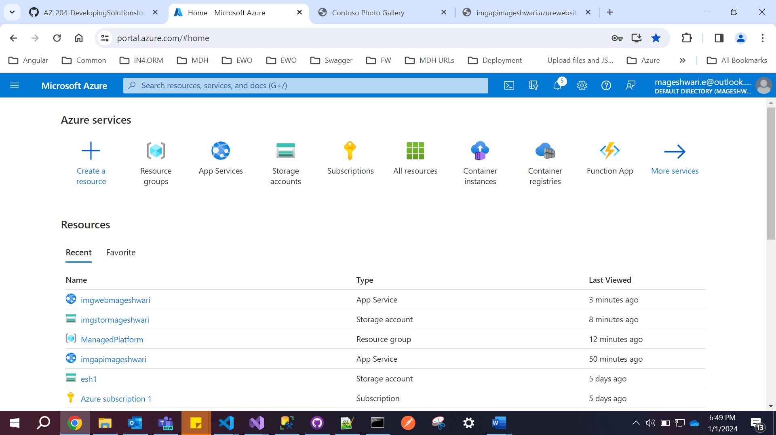

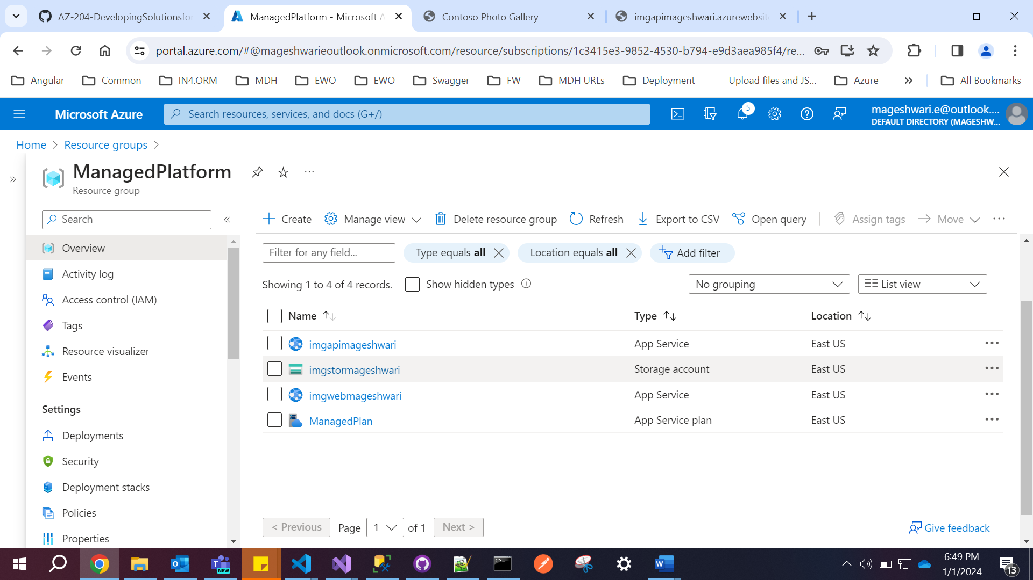

**Lab 2**

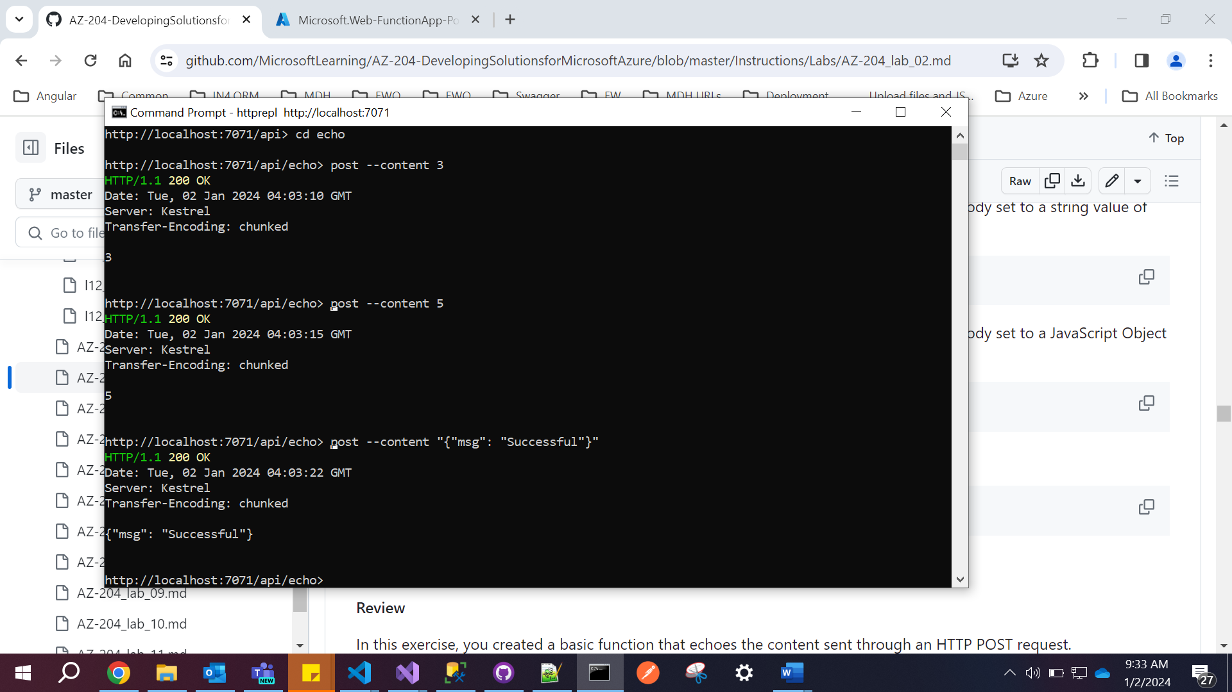

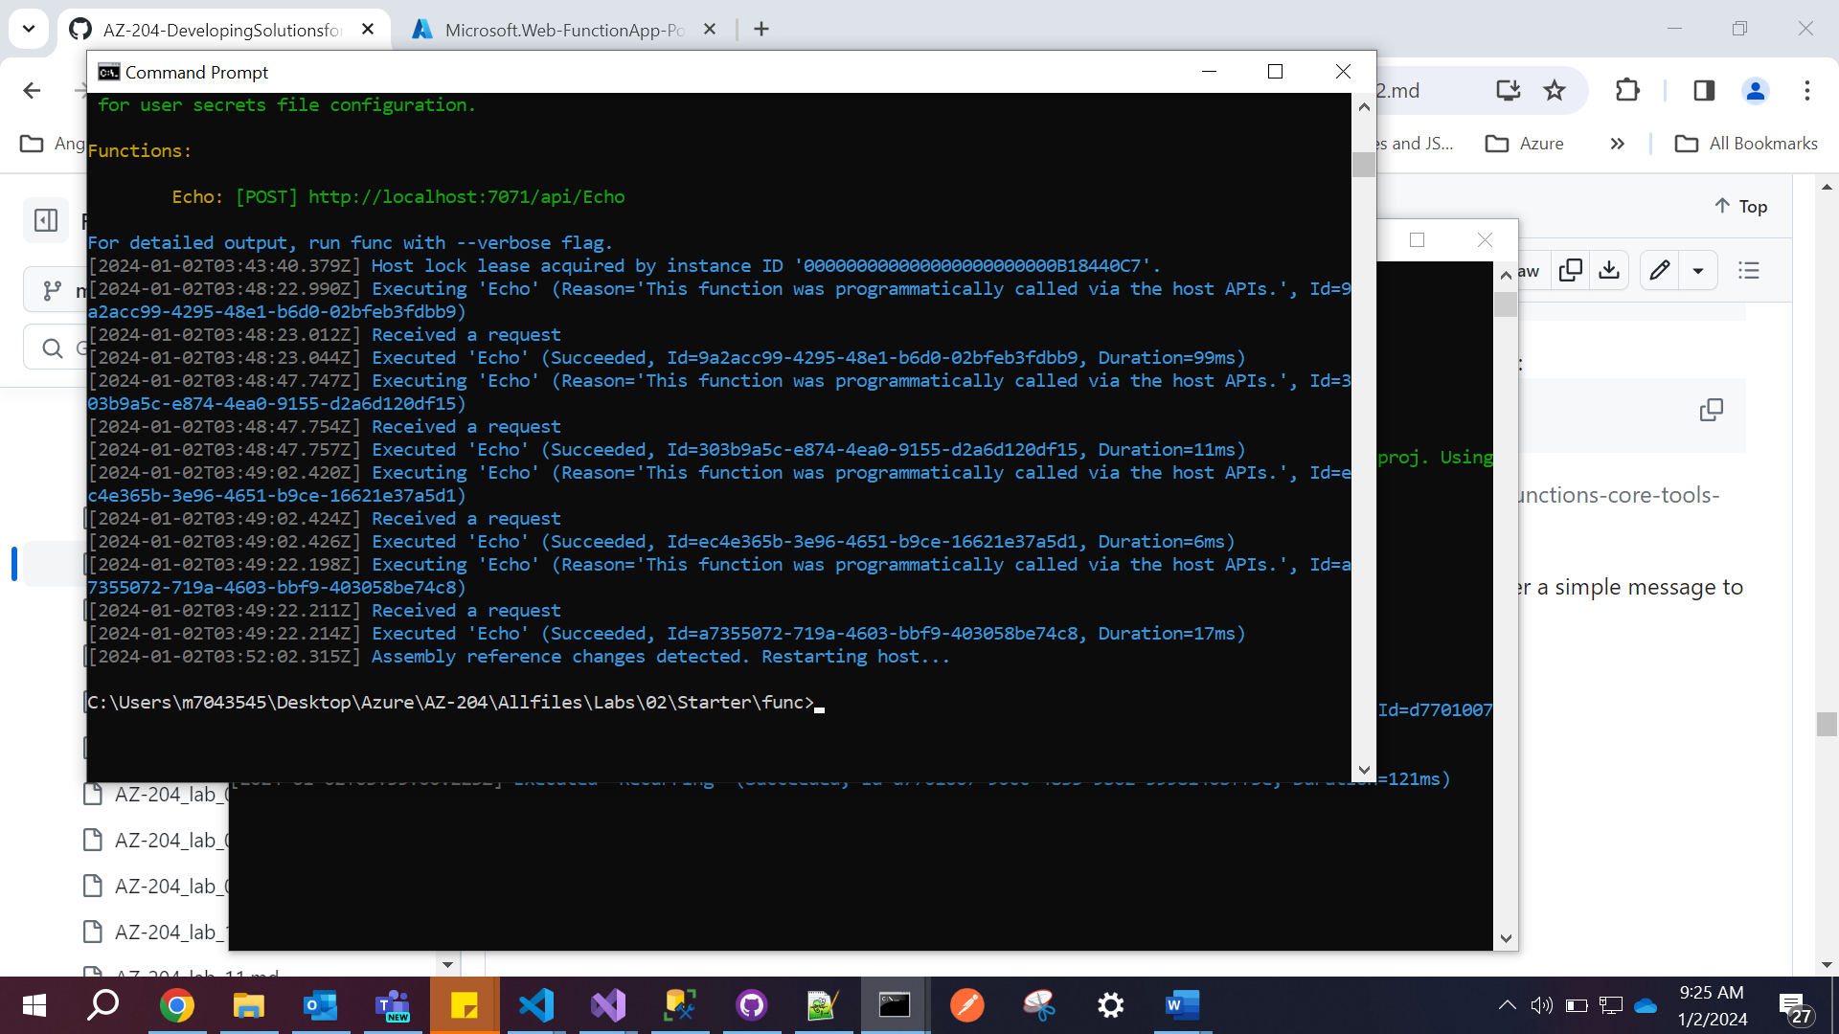

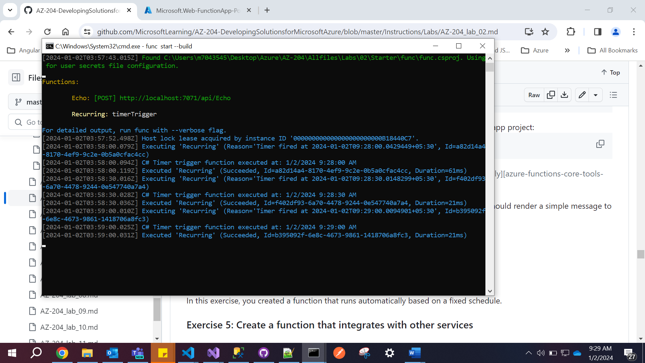

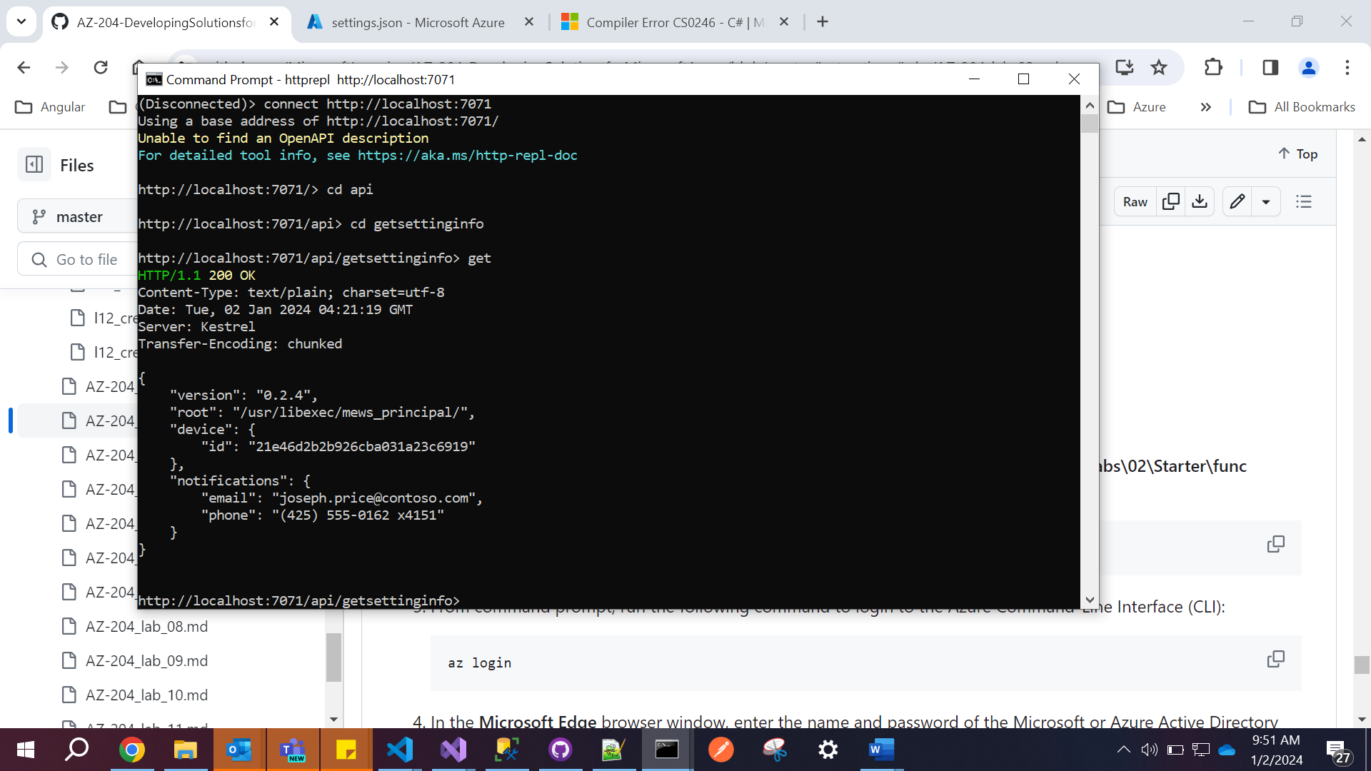

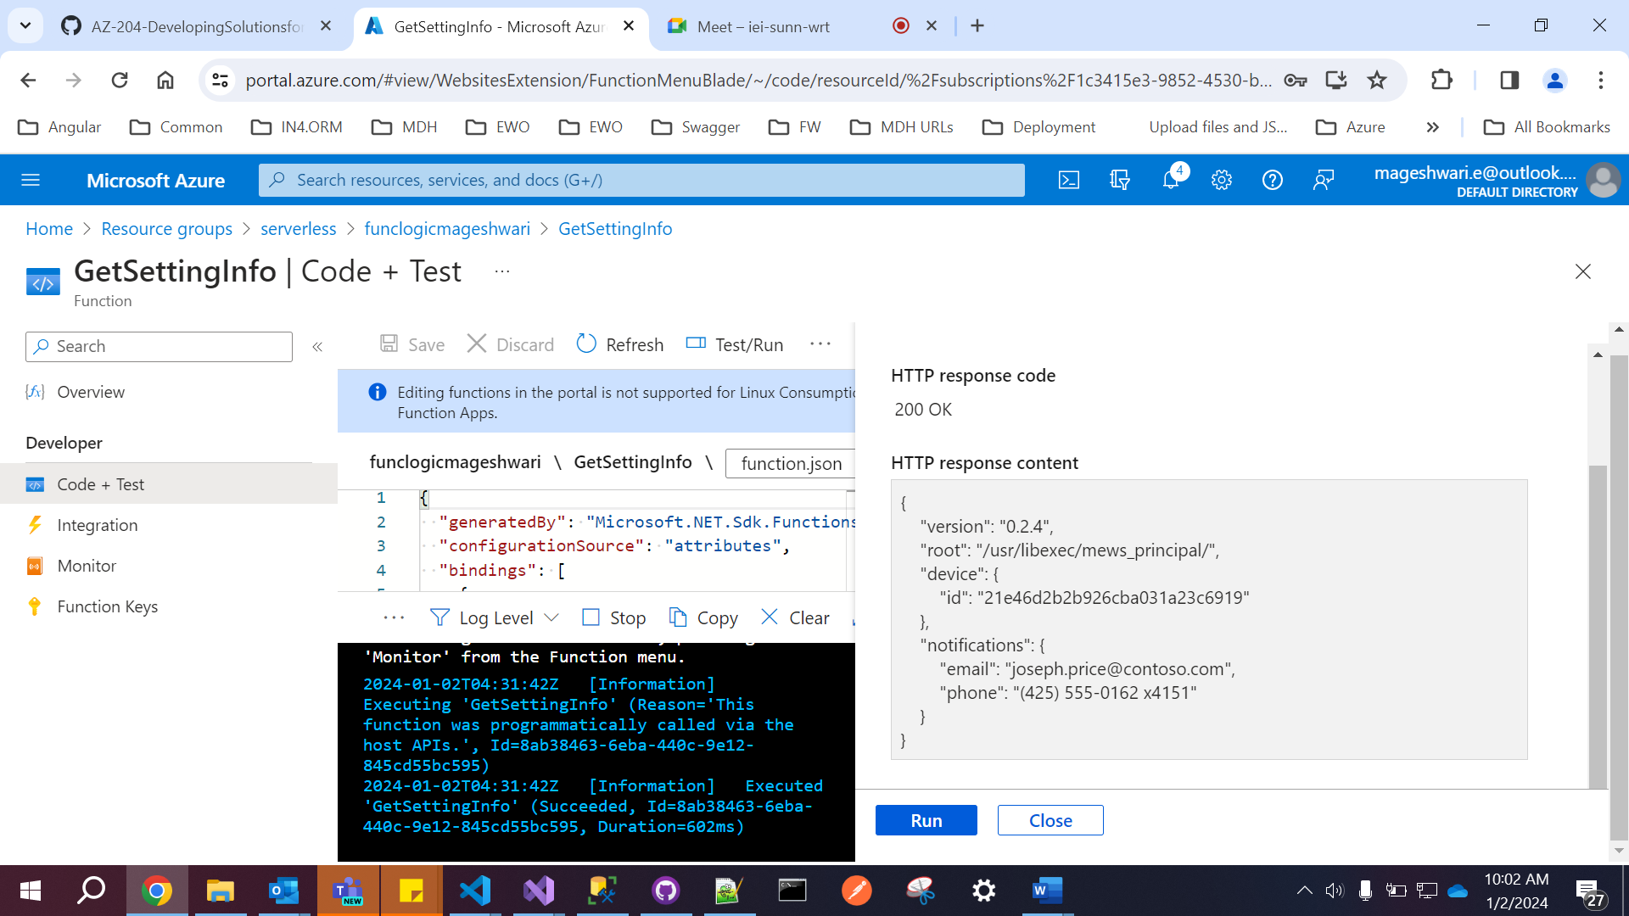

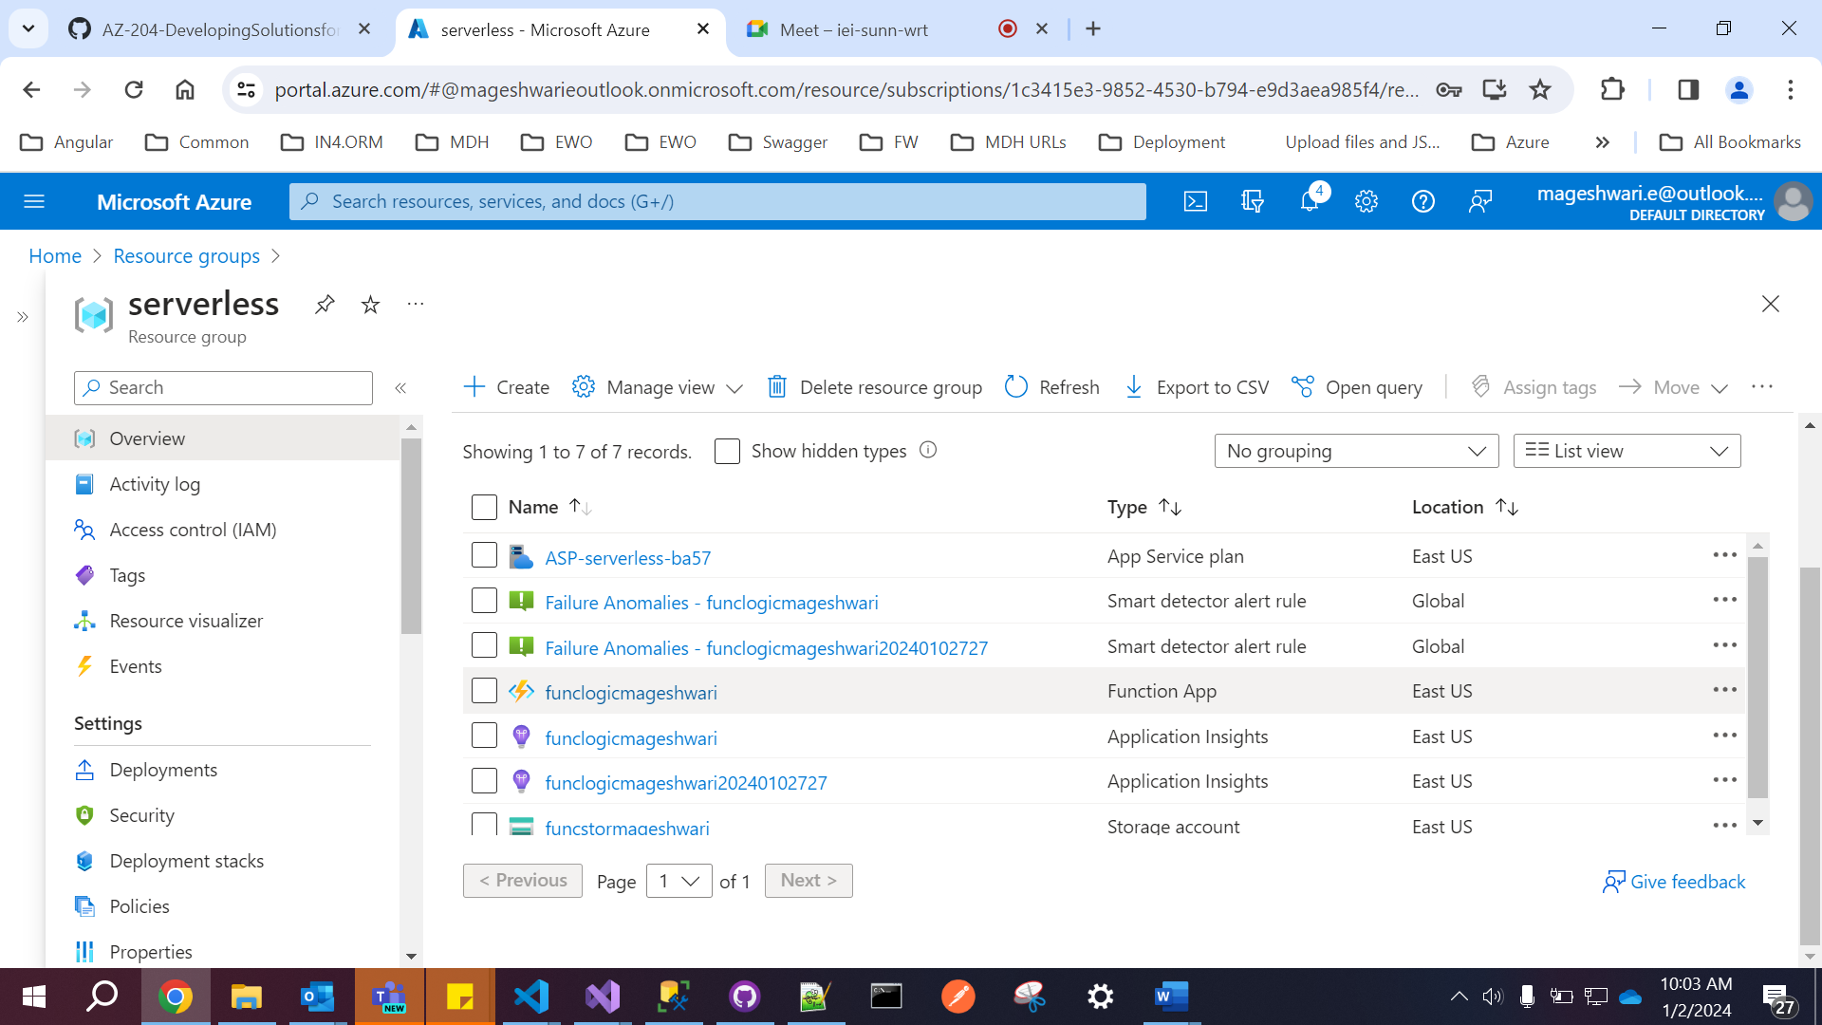

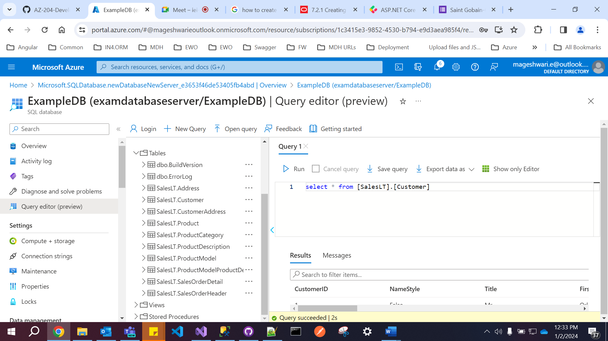

**Lab 3**

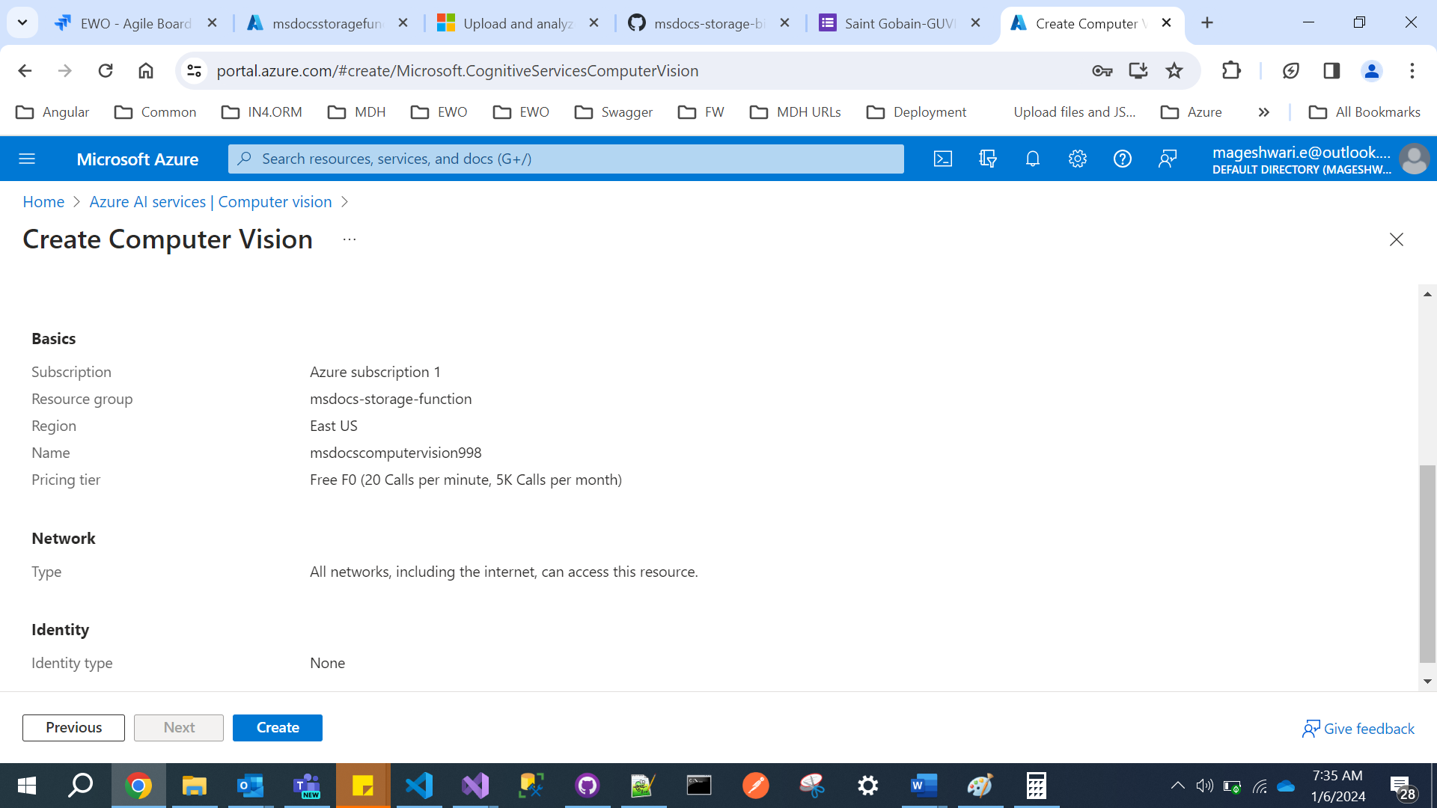

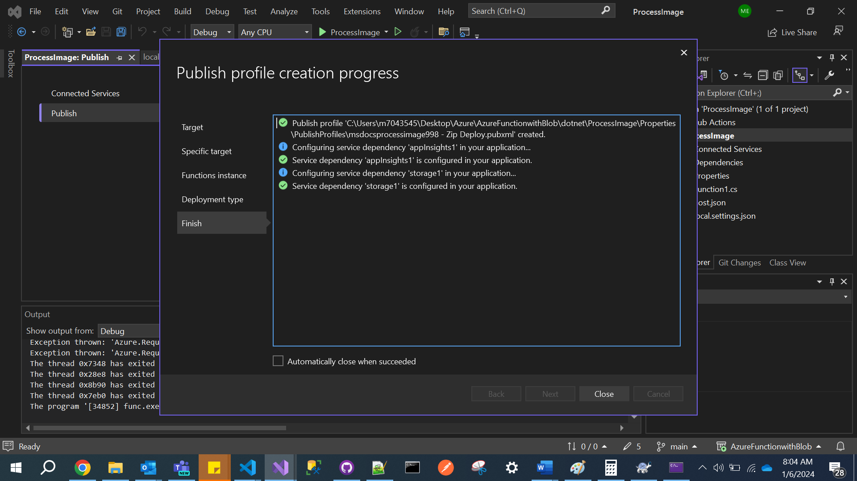

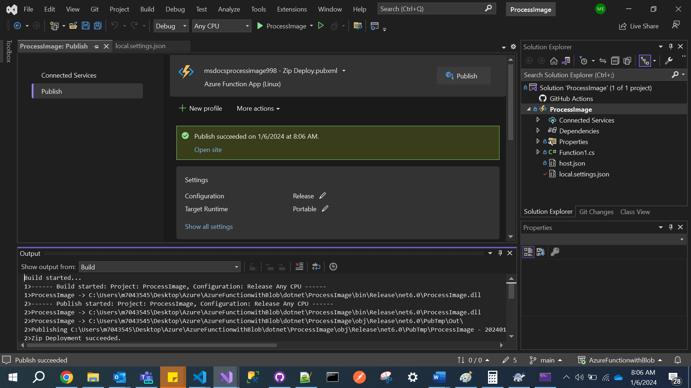

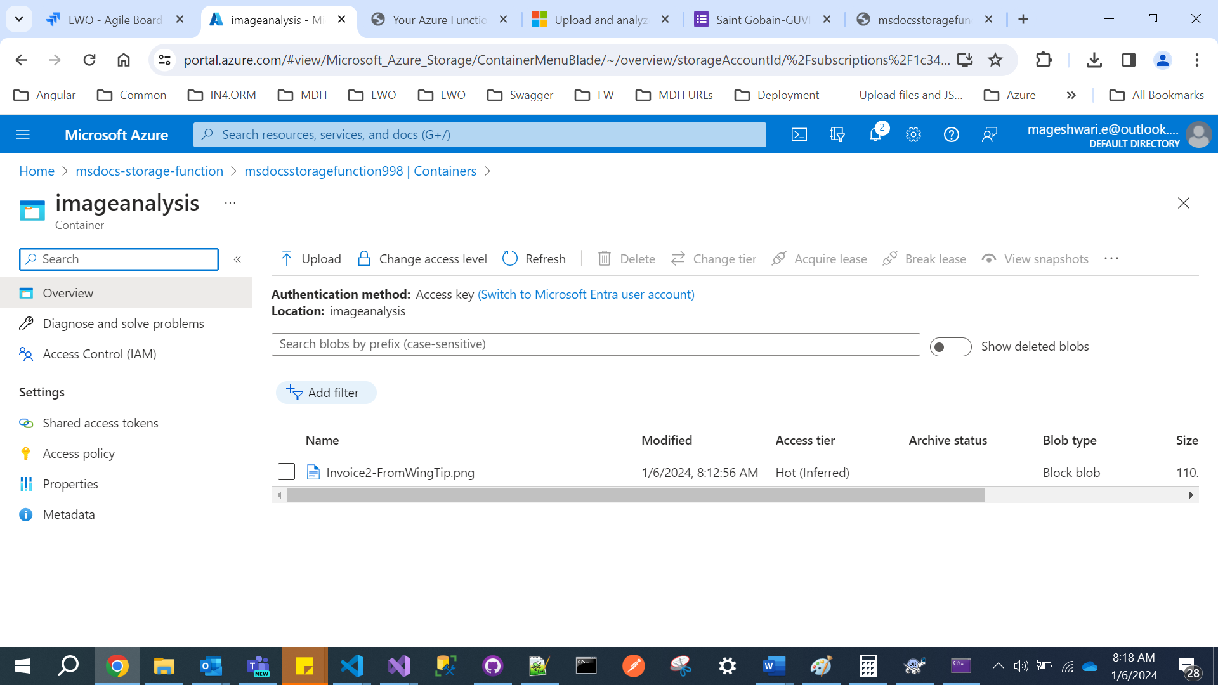

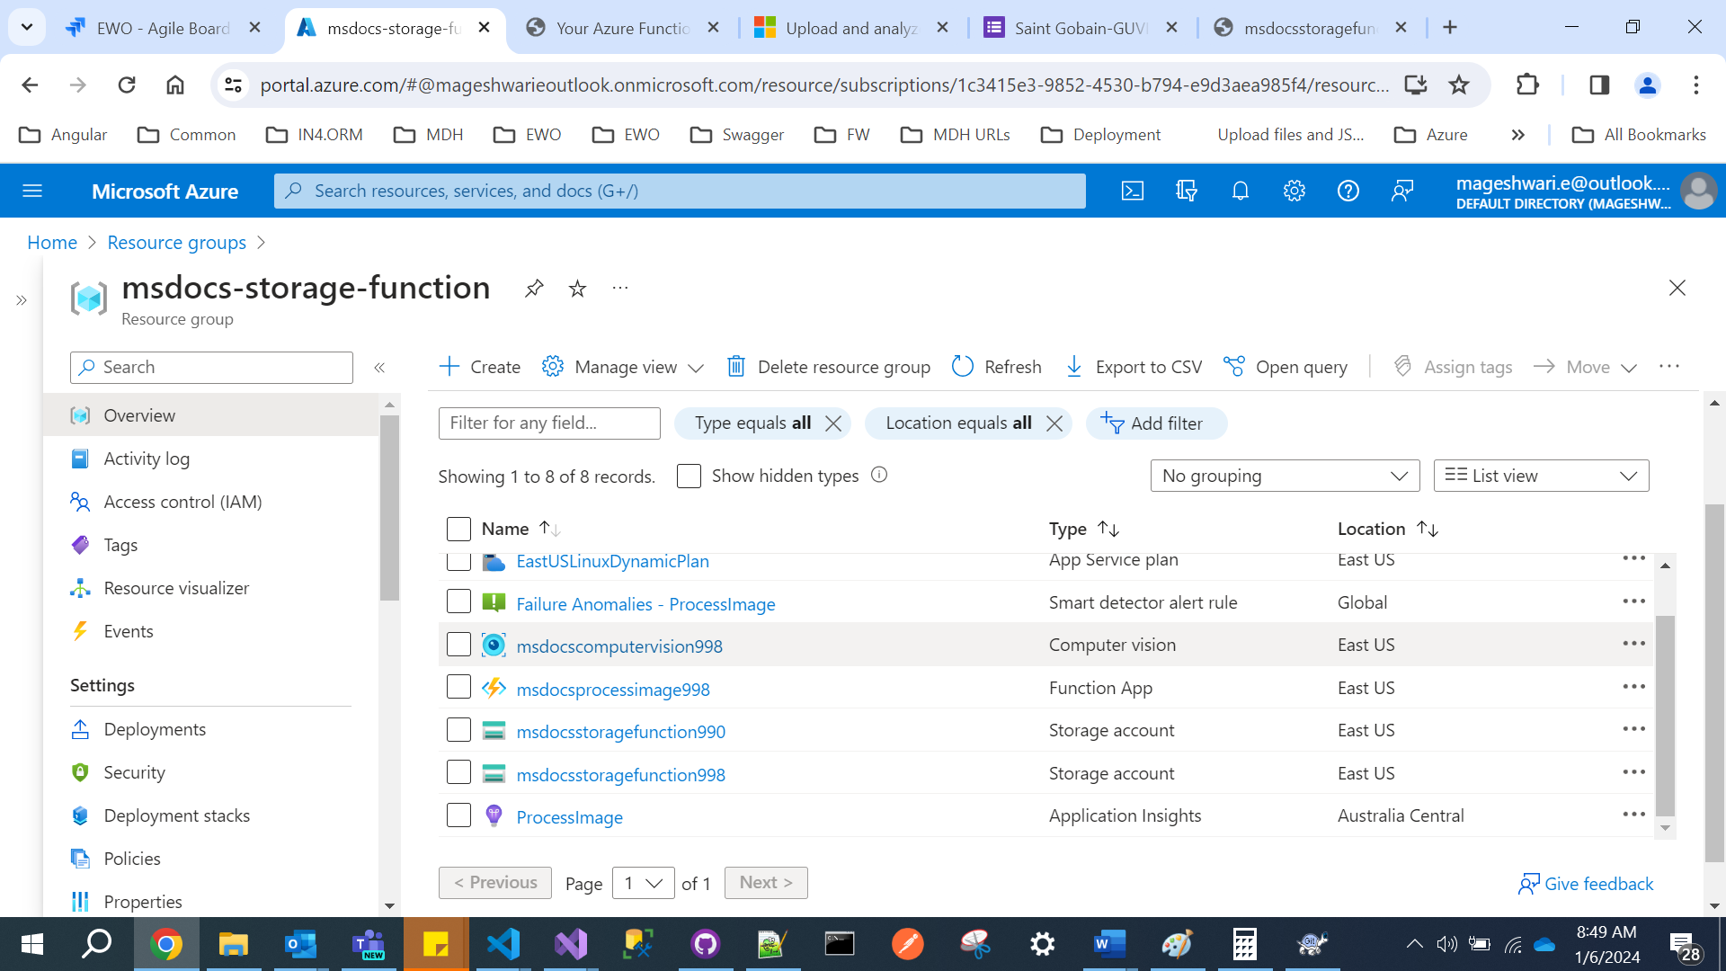

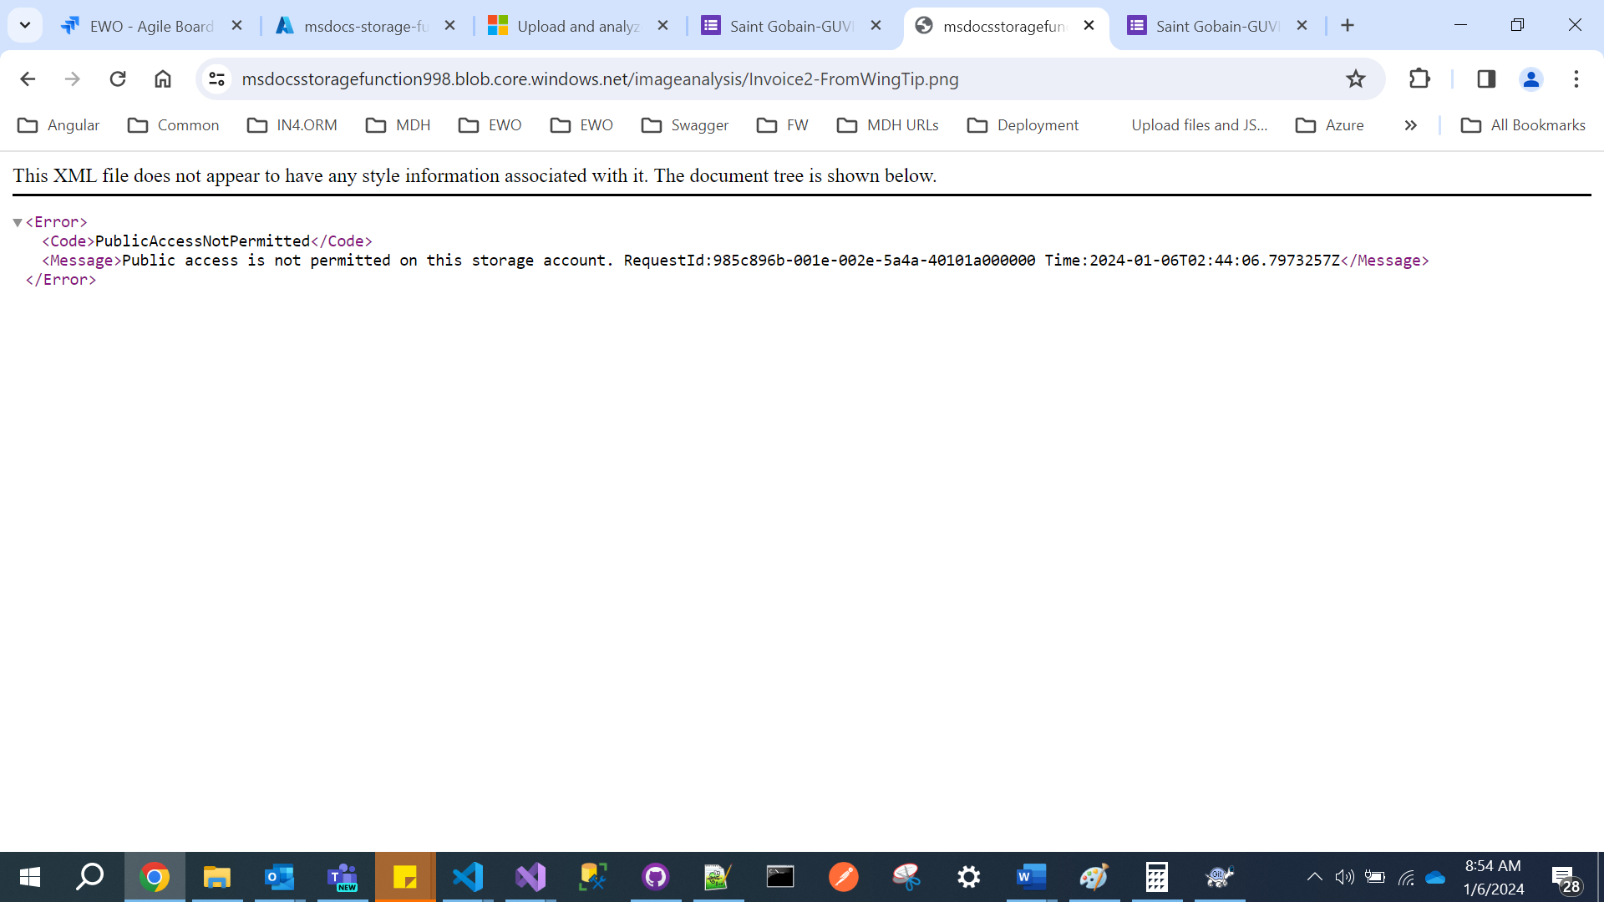

**Azure cache for Redis**

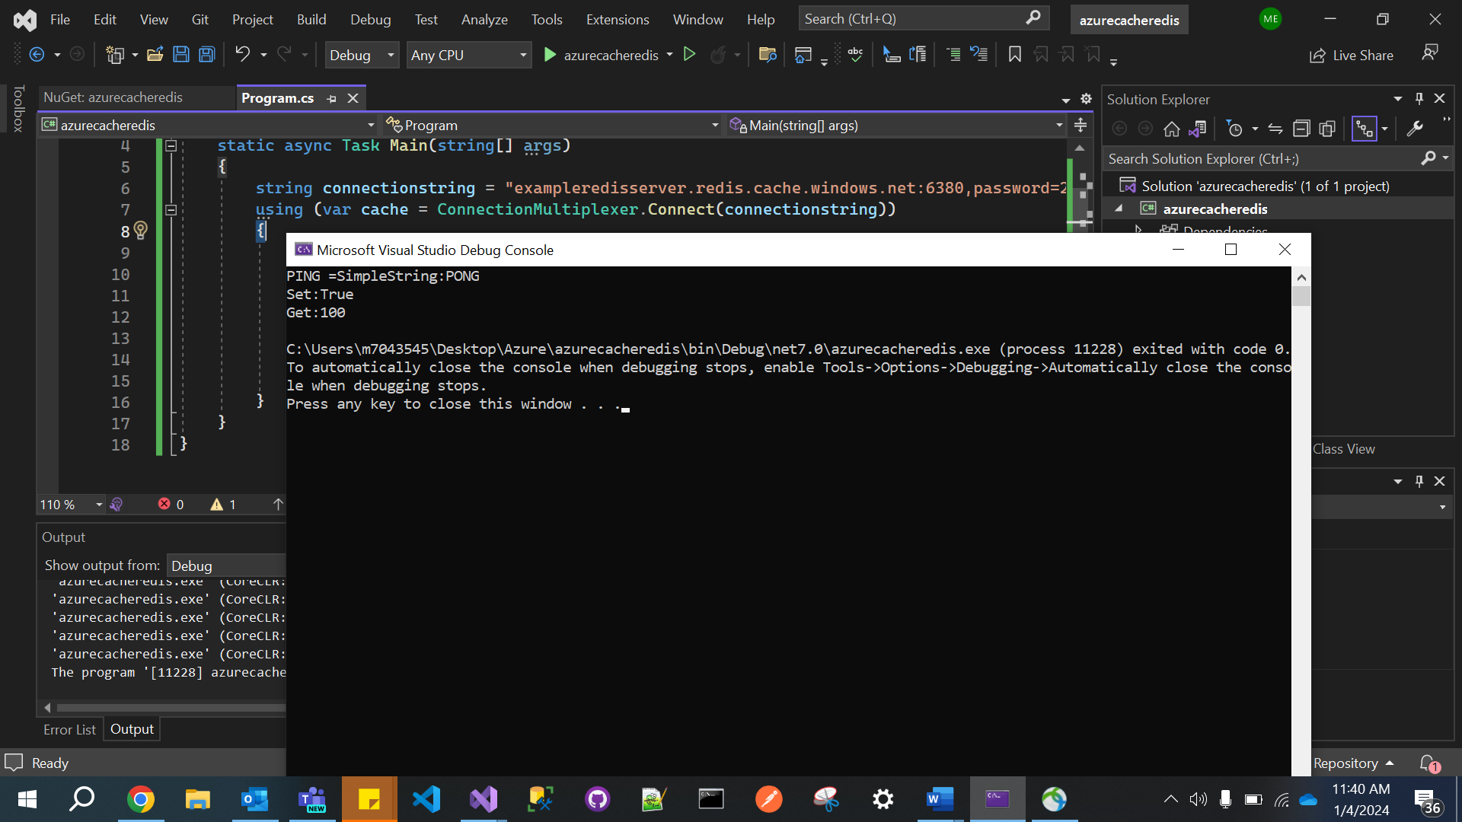

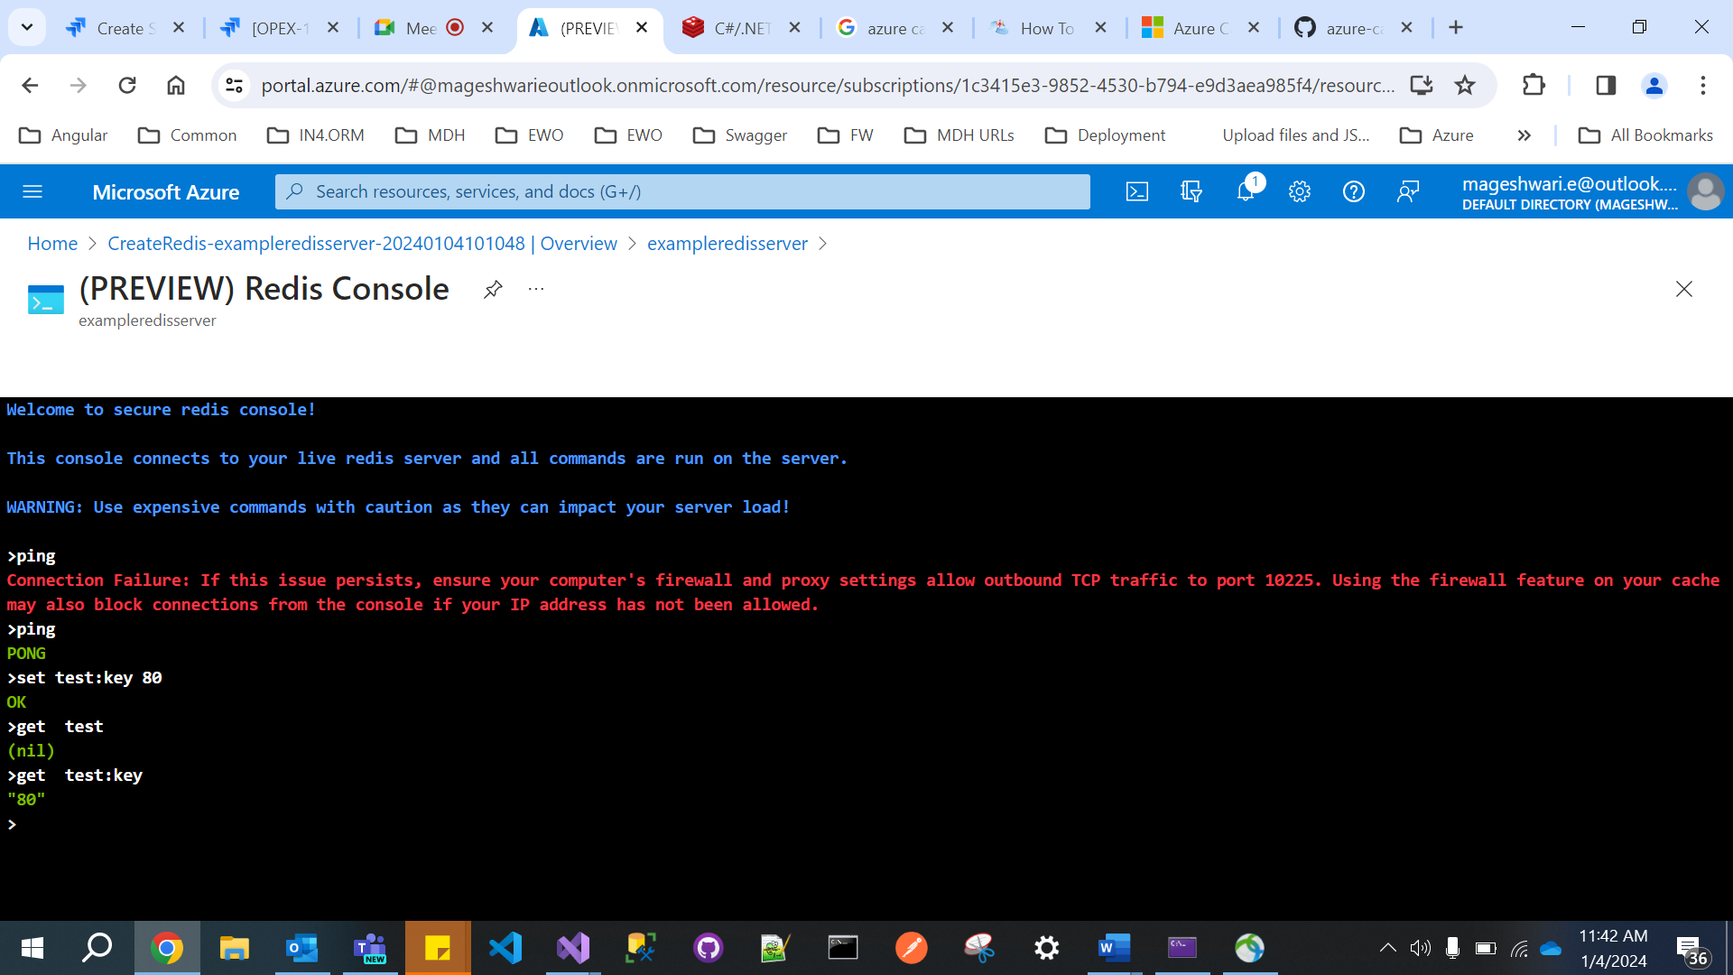

**Key Vault**

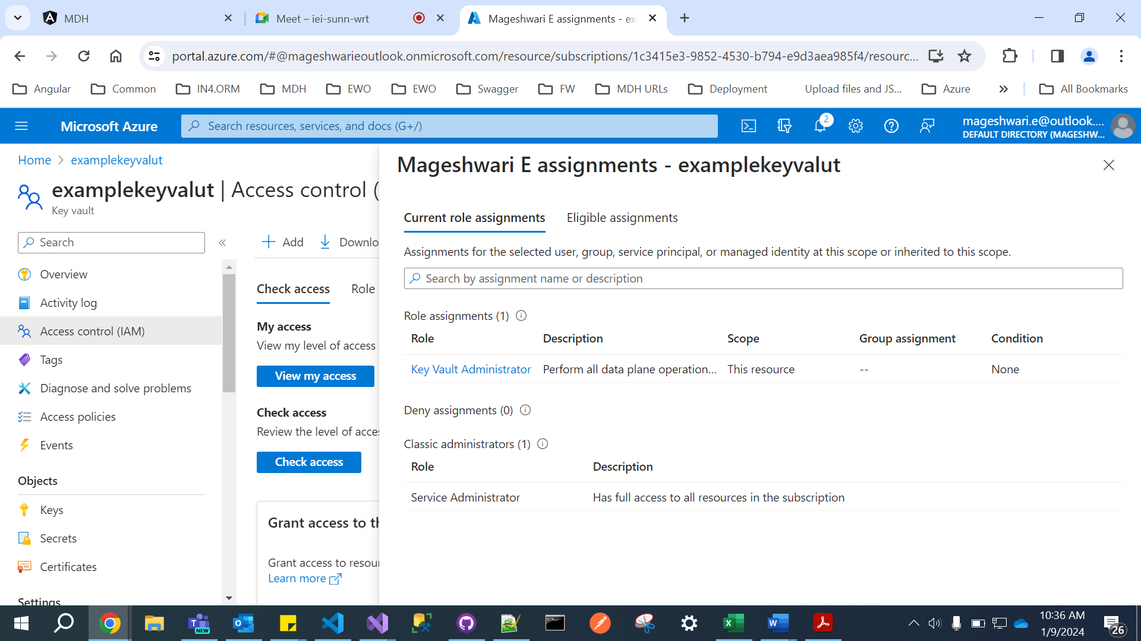

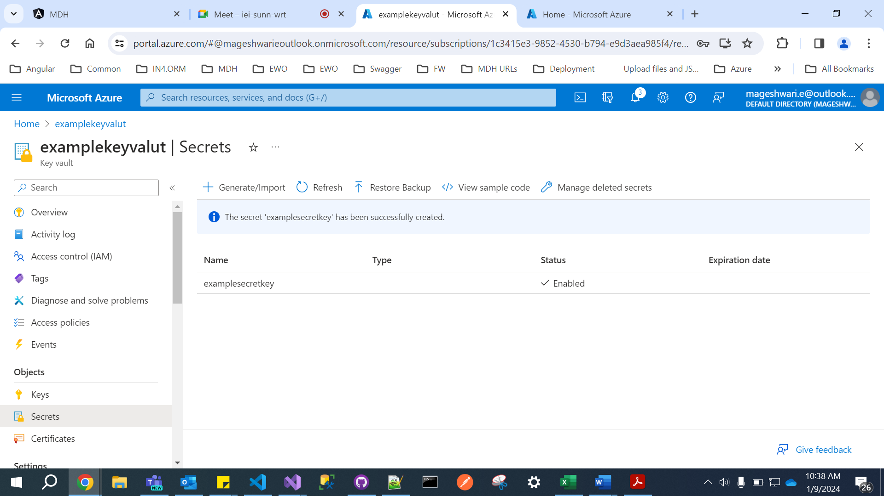

https://examplekeyvalut.vault.azure.net/secrets/examplesecretkey/e9f3761a4b9c493b993e60693a5259e9

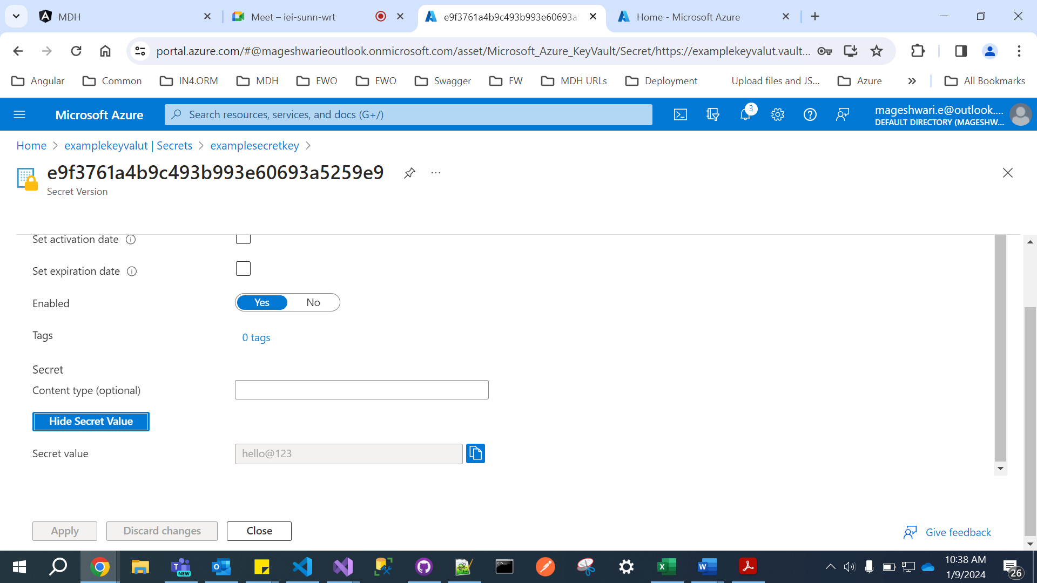

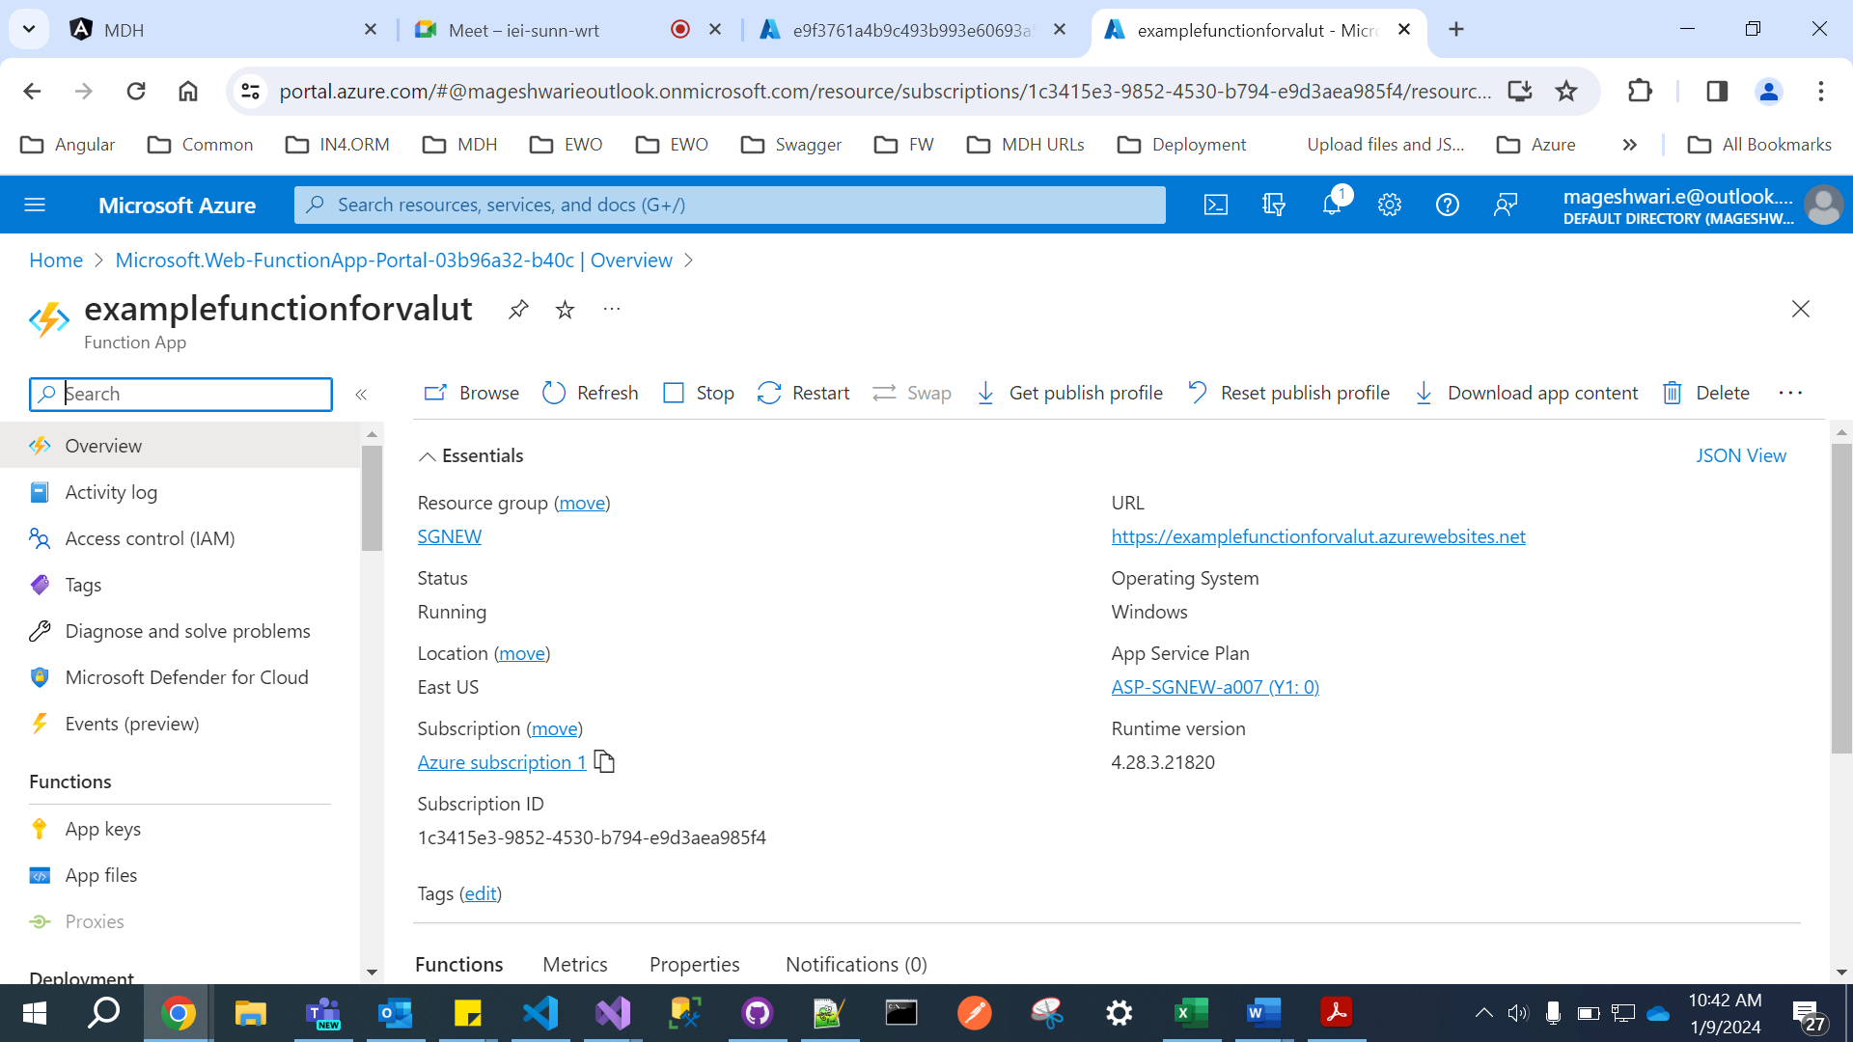

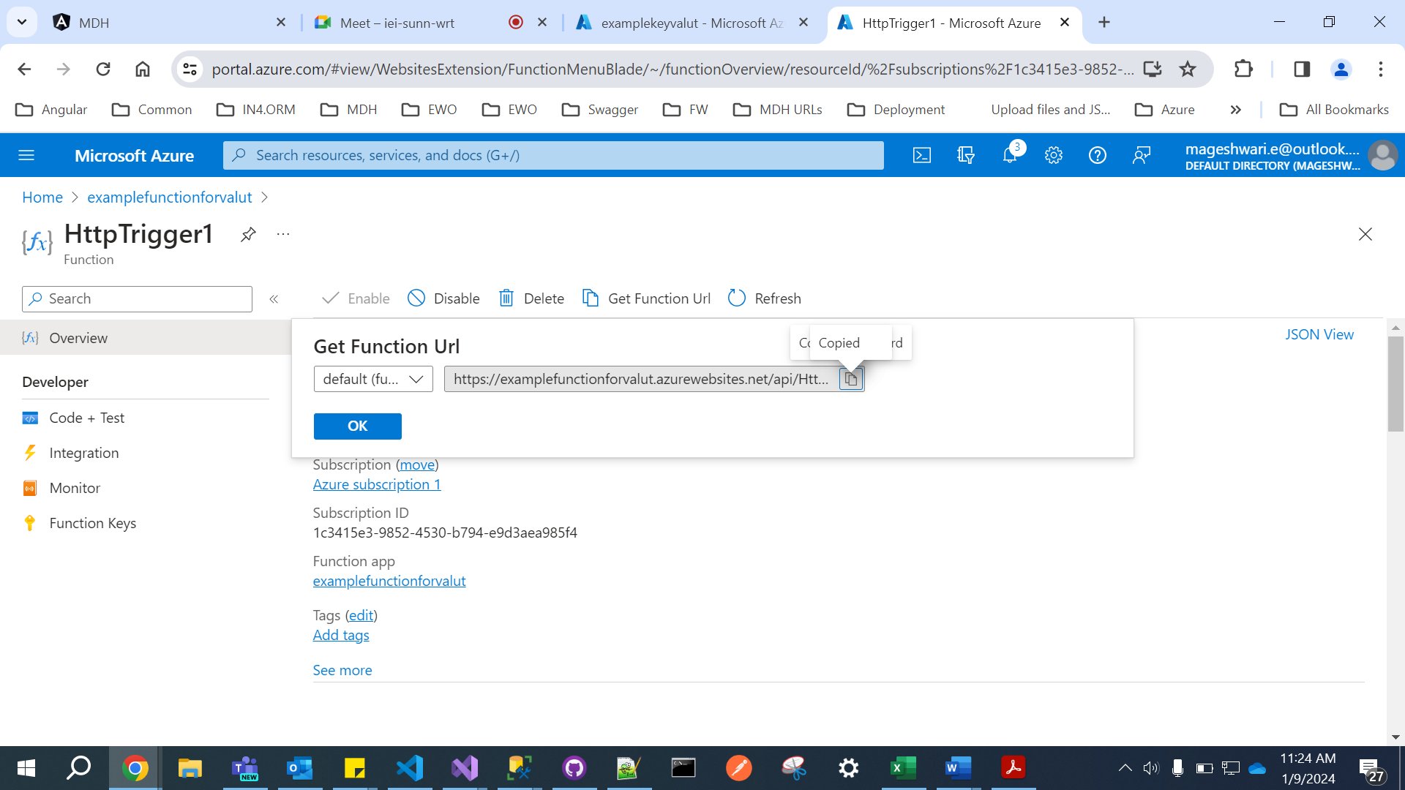

01f34506-66cd-46b3-b4c2-fd0da95922af

<https://examplefunctionforvalut.azurewebsites.net/api/HttpTrigger1?code=JVXss-mIDQdz0DieBje-suJyOGxr0XNAsTvr0MZANiUbAzFu_9jiyA==>

Secret Identifier:

https://examplekeyvalut.vault.azure.net/secrets/examplesecretkey/e9f3761a4b9c493b993e60693a5259e9

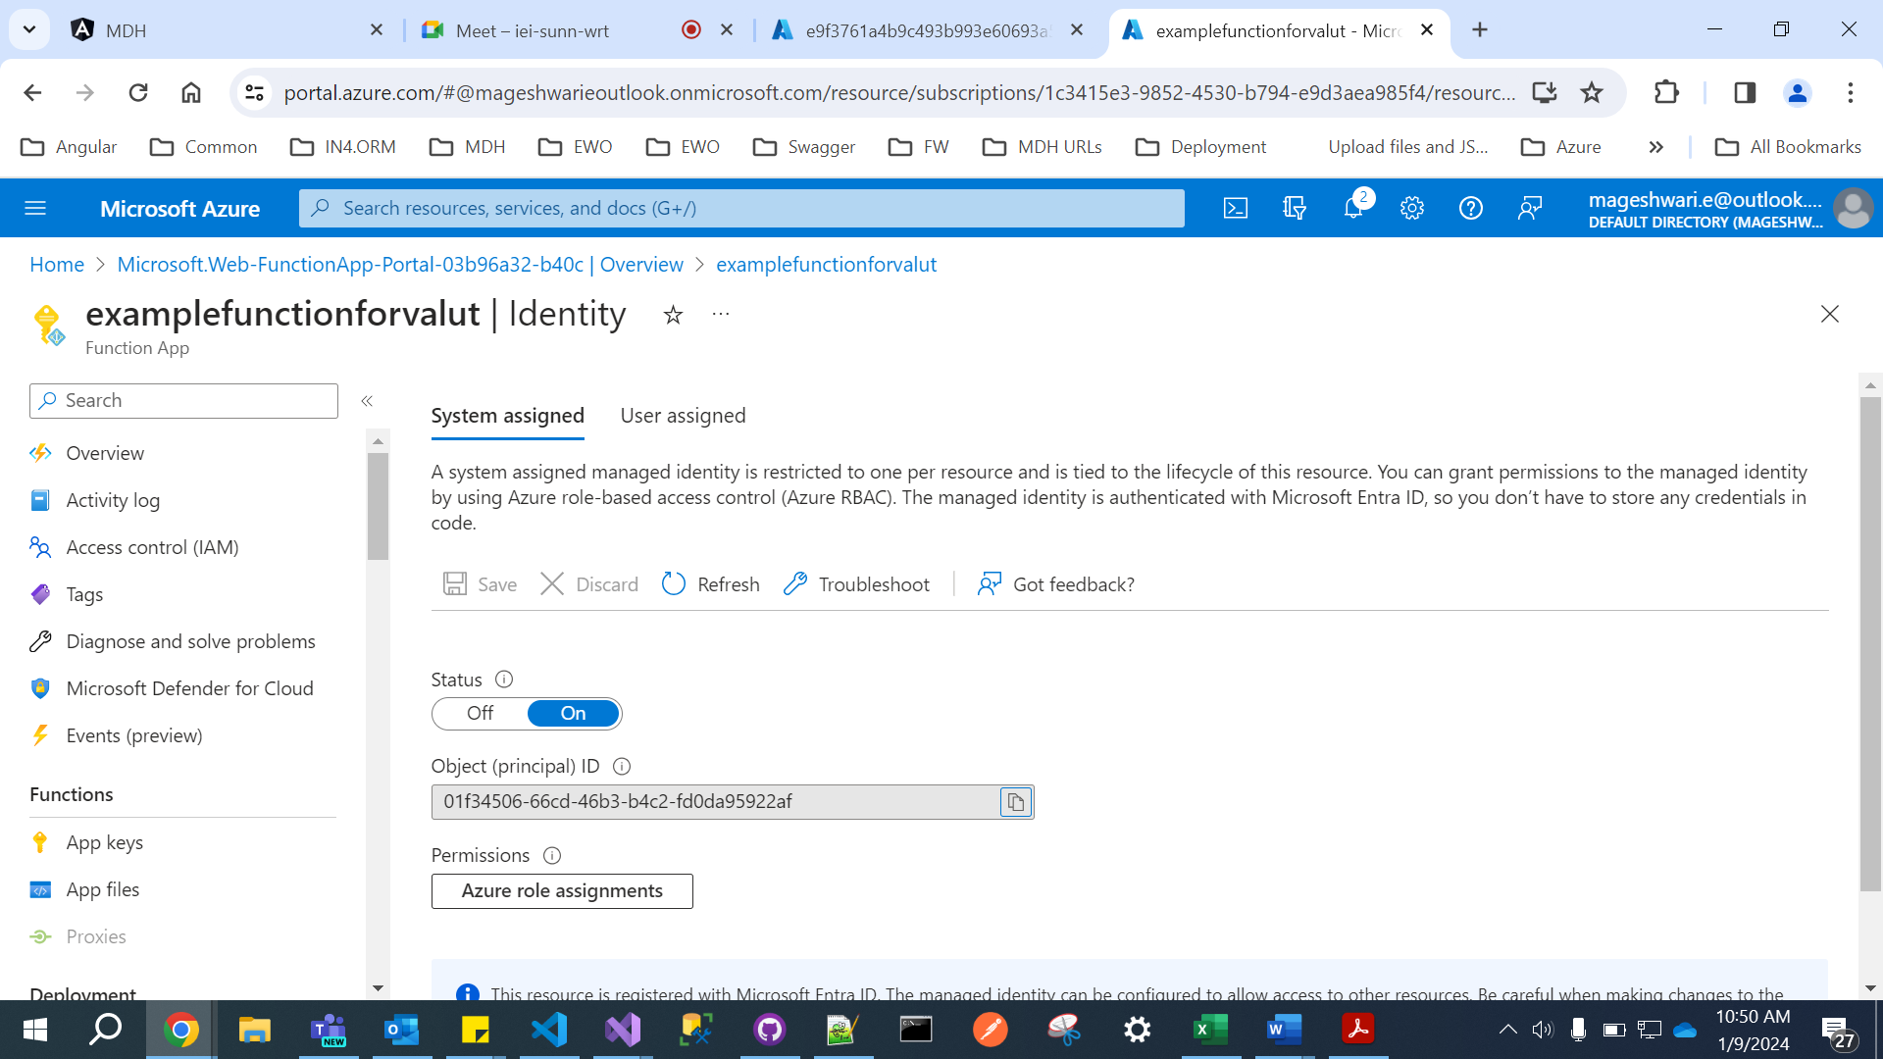

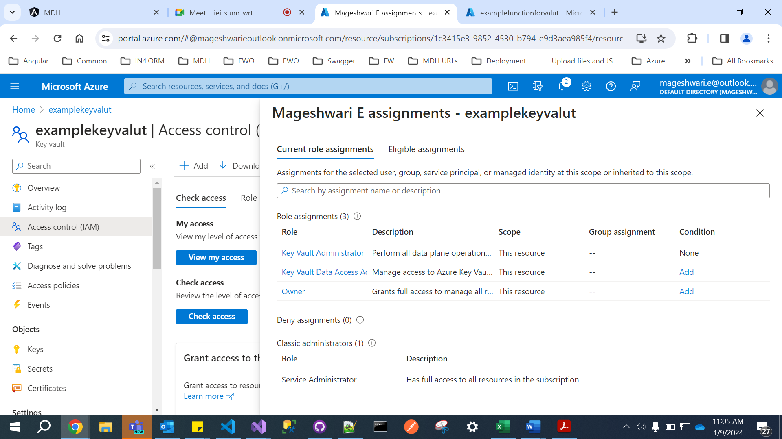

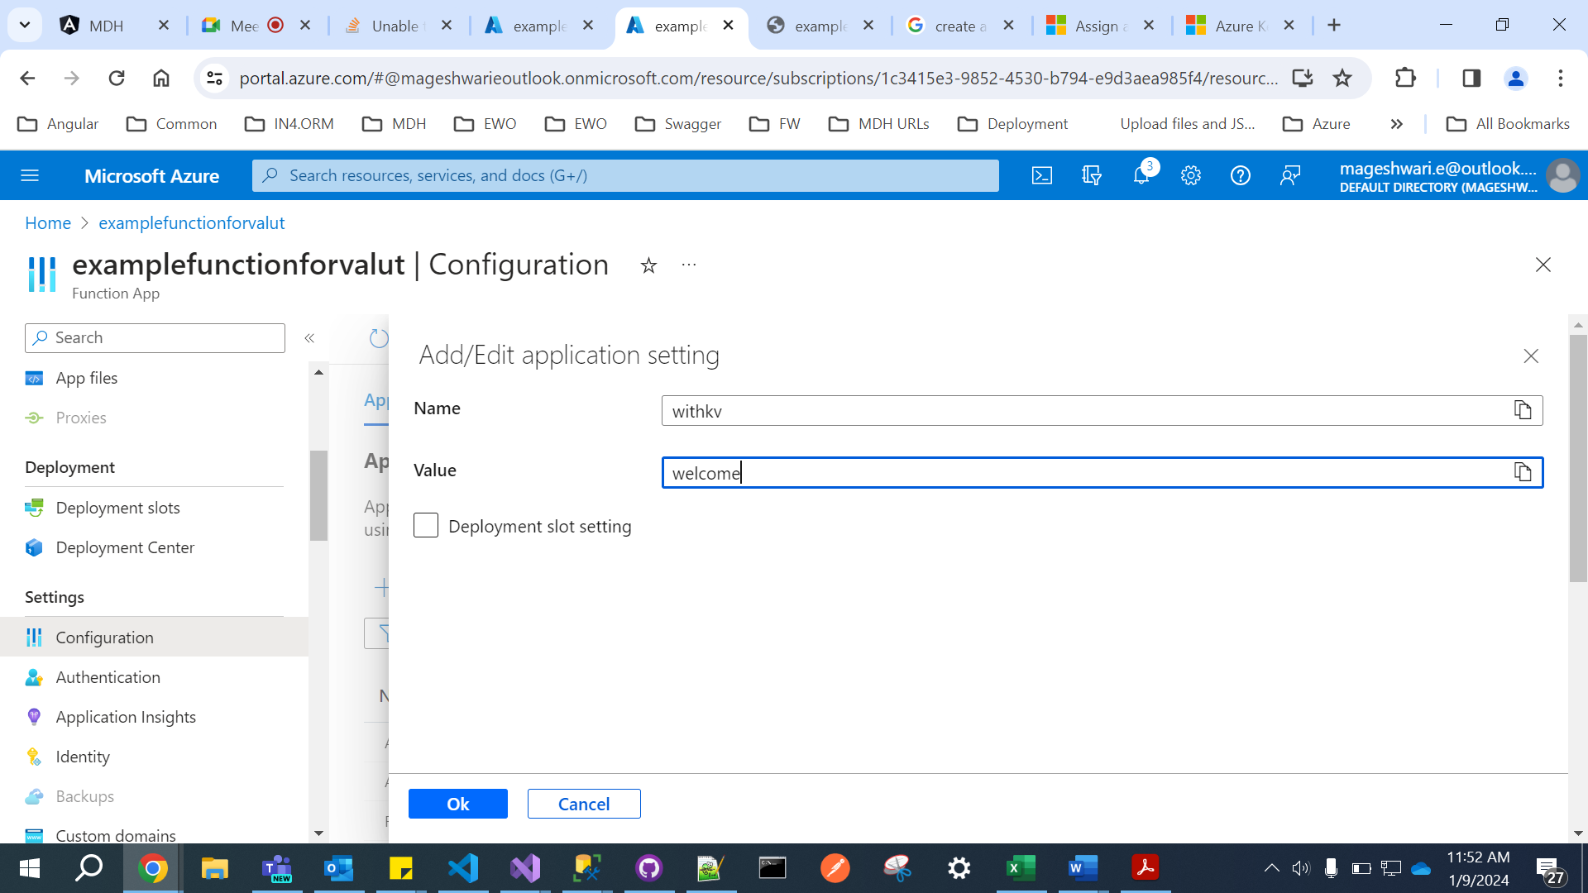

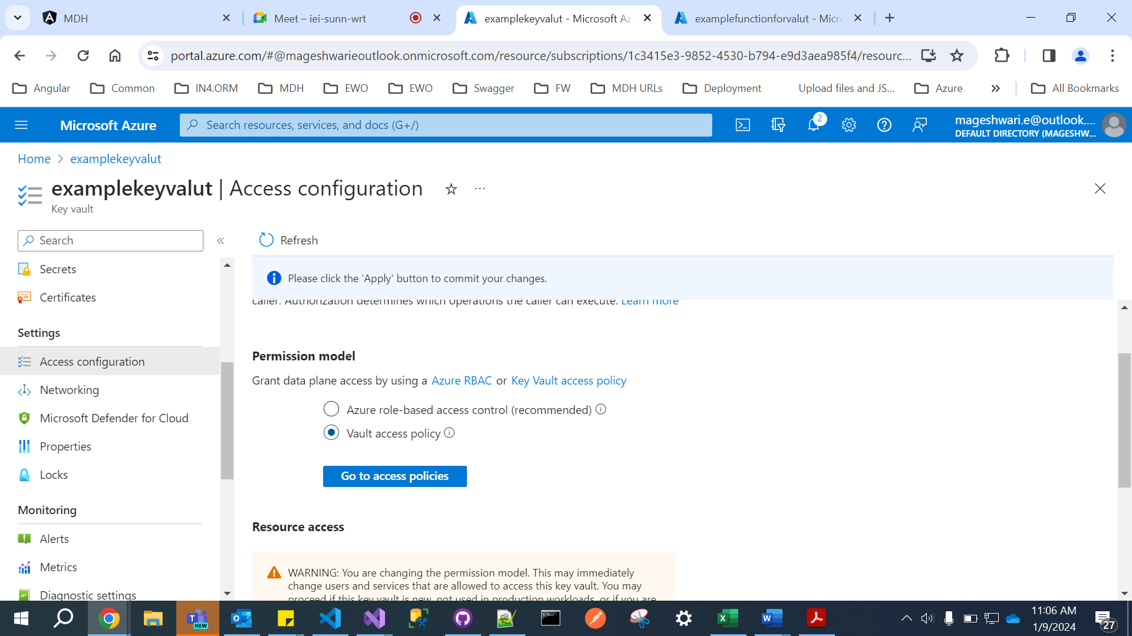

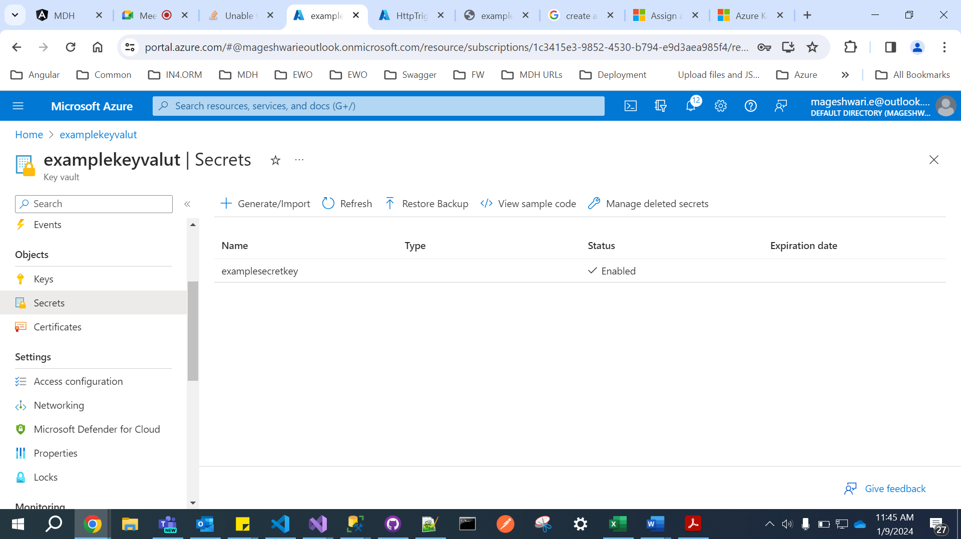

@Microsoft.KeyVault(SecretUri=https://examplekeyvalut.vault.azure.net/secrets/examplesecretkey/e9f3761a4b9c493b993e60693a5259e9)

string value1=Environment.GetEnvironmentVariable("withoutkv"); string value2= Environment.GetEnvironmentVariable("withkv"); log.LogInformation("C# HTTP trigger function processed a request."); log.LogInformation($"Wihtout KV => {value1}"); log.LogInformation($"With KV => {value2}"); return new OkObjectResult(value2);

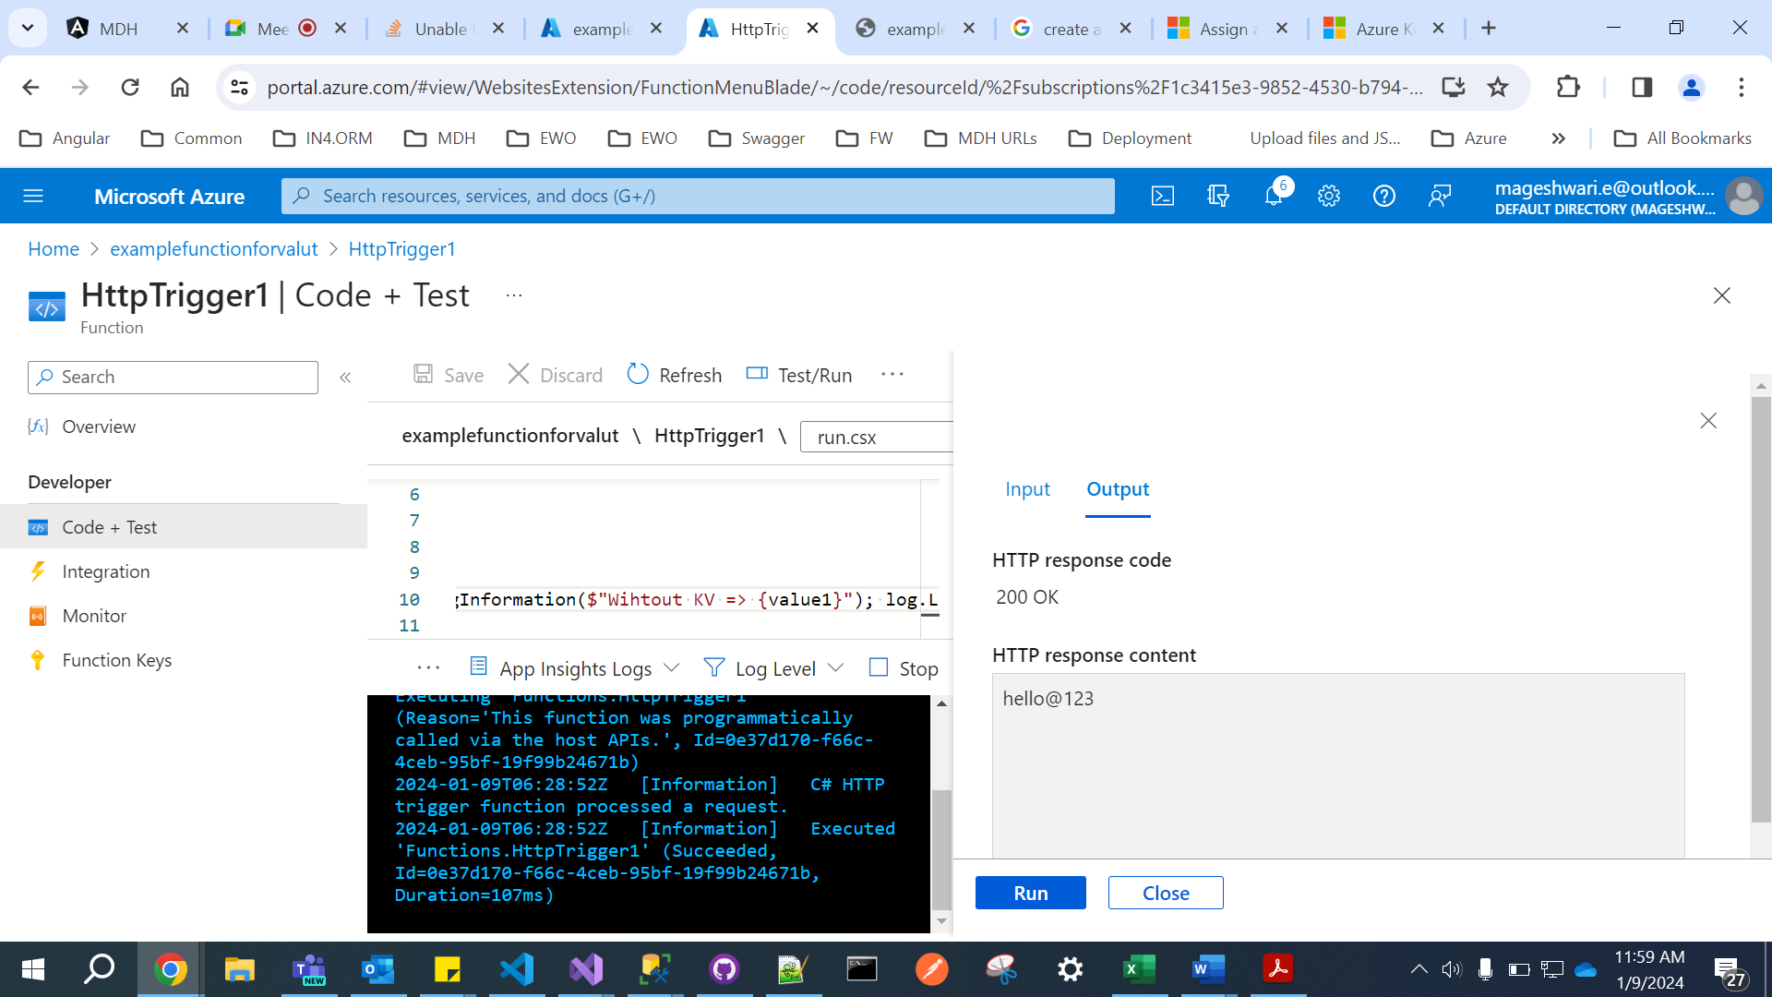

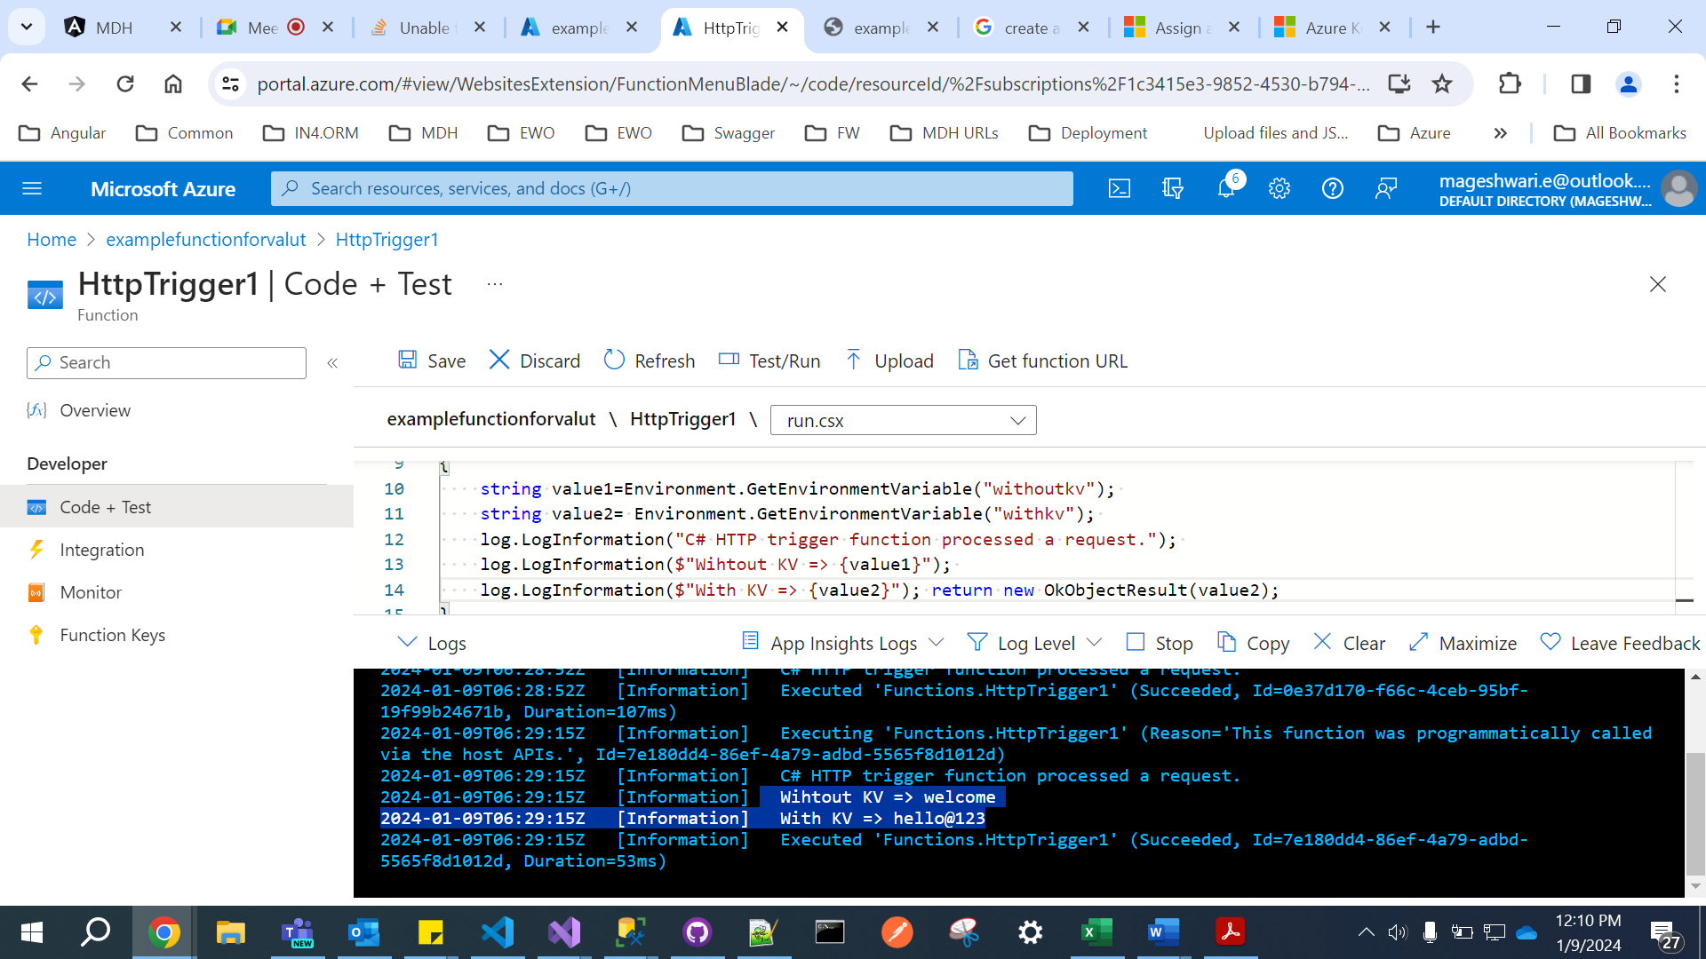

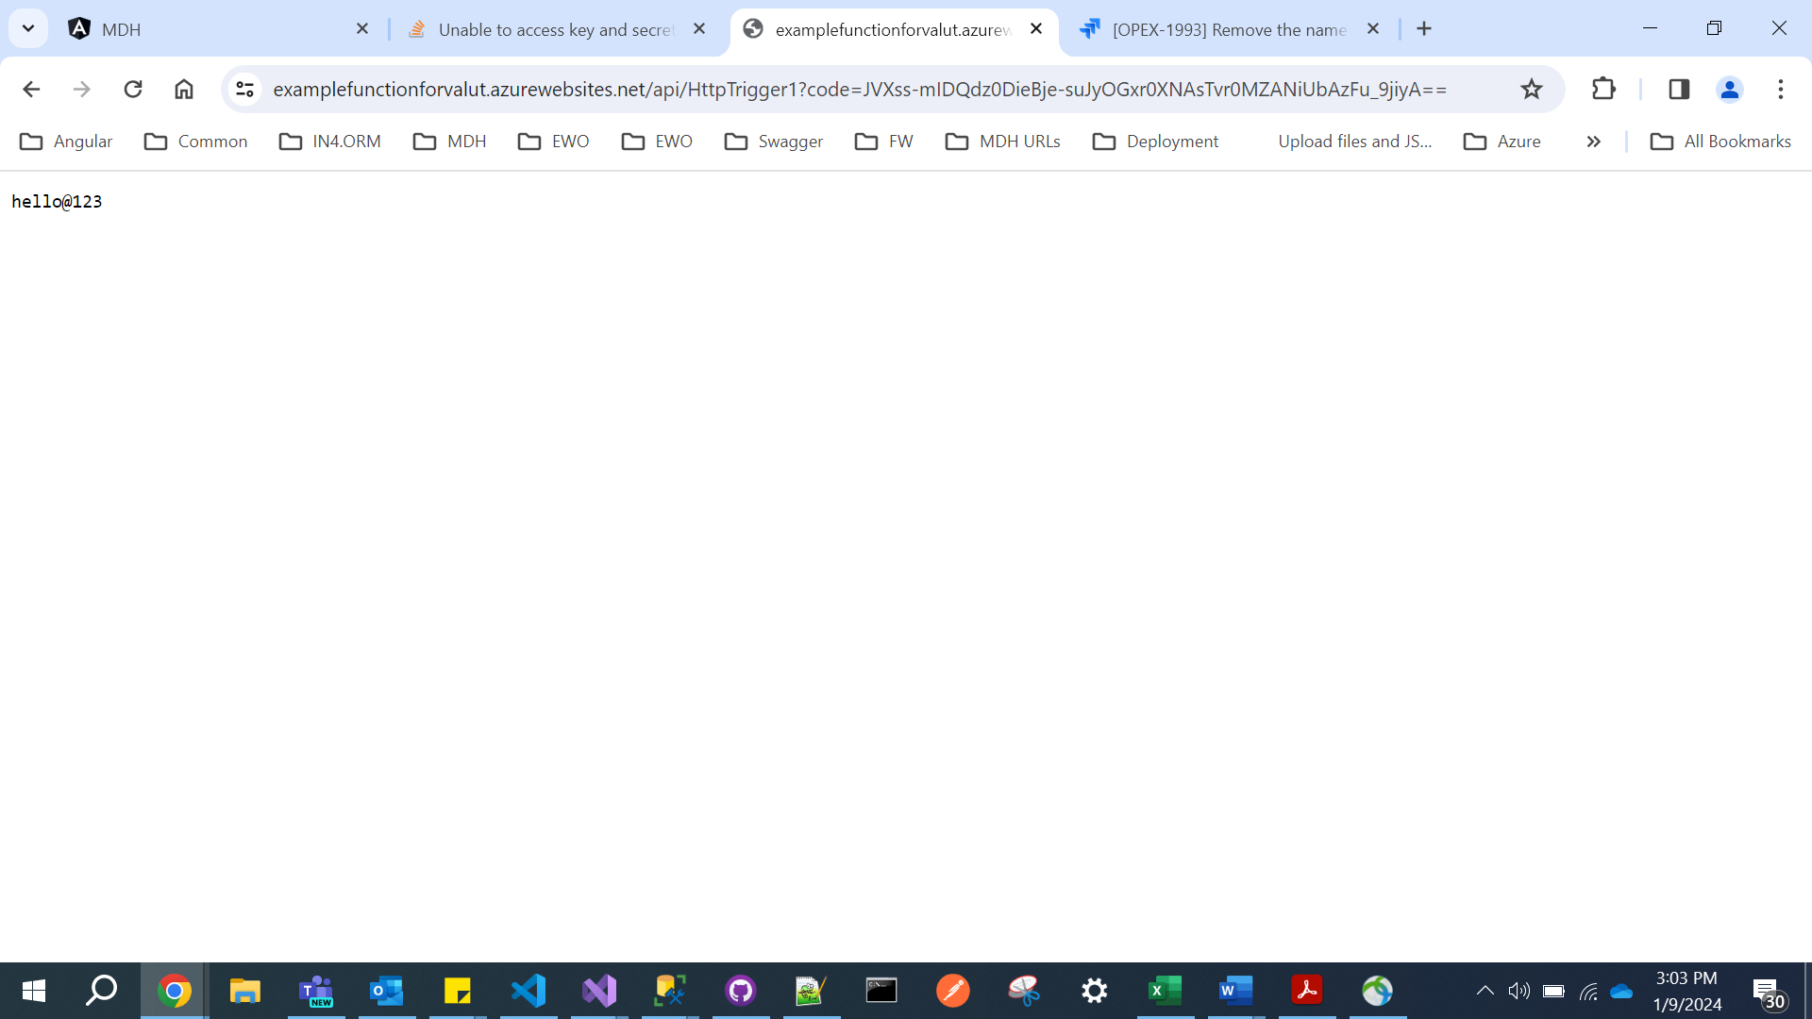

**Lab 6:**

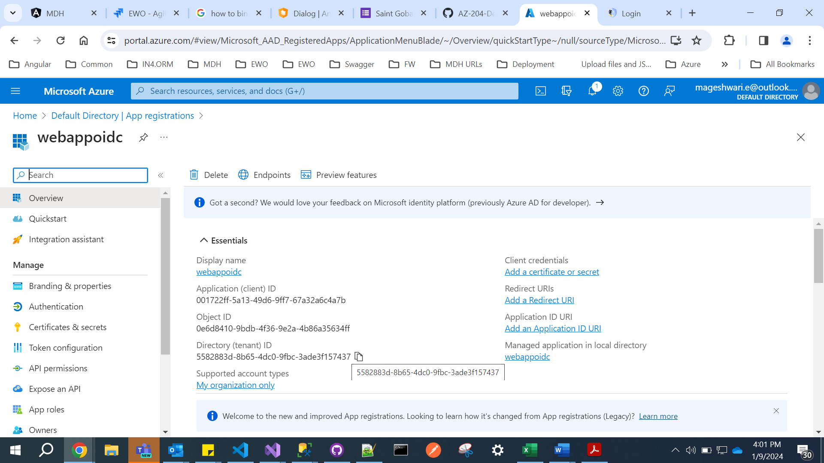

ClientId : 001722ff-5a13-49d6-9ff7-67a32a6c4a7b

Directory(tenantID) : 5582883d-8b65-4dc0-9fbc-3ade3f157437

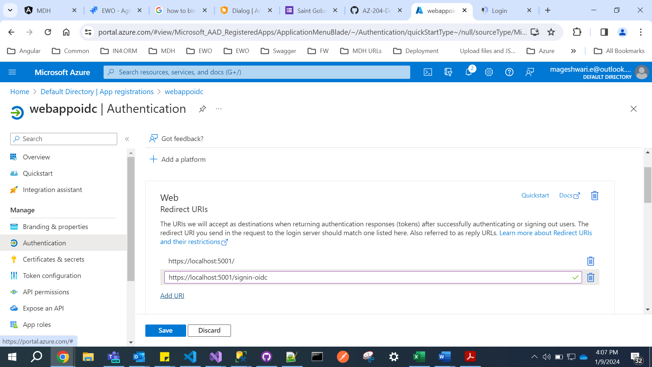

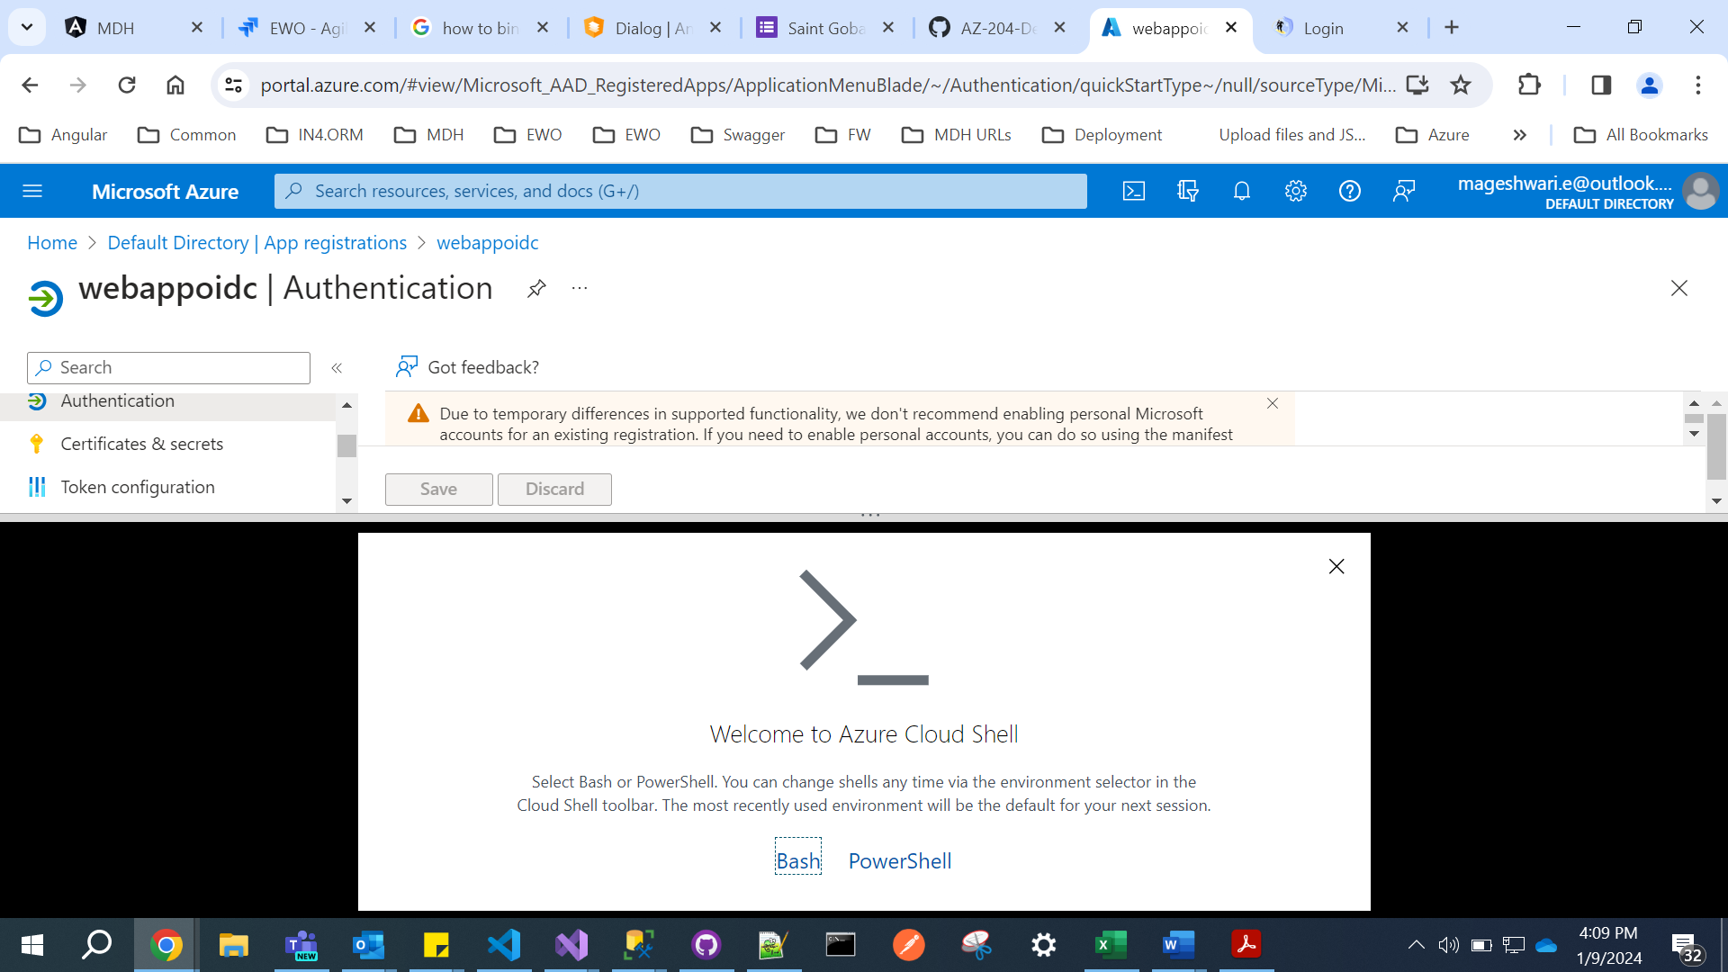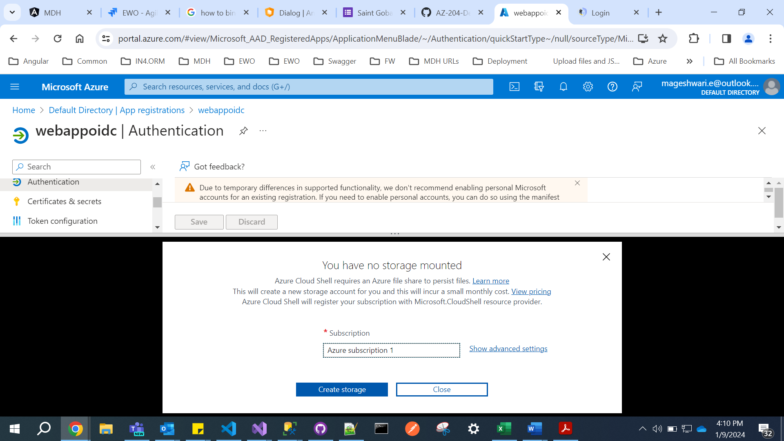

001722ff-5a13-49d6-9ff7-67a32a6c4a7b

dotnet new mvc --auth SingleOrg --client-id 001722ff-5a13-49d6-9ff7-67a32a6c4a7b --tenant-id 5582883d-8b65-4dc0-9fbc-3ade3f157437 --domain webappoidc

rmdir .\obj /S /Q

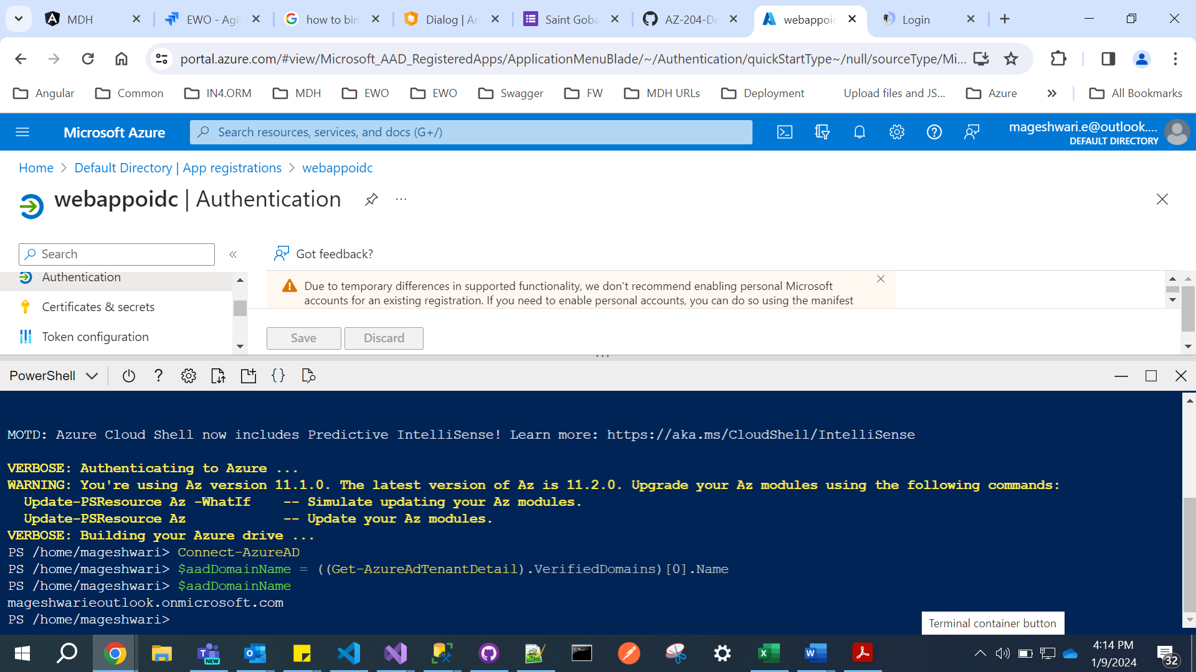

mageshwarieoutlook.onmicrosoft.com

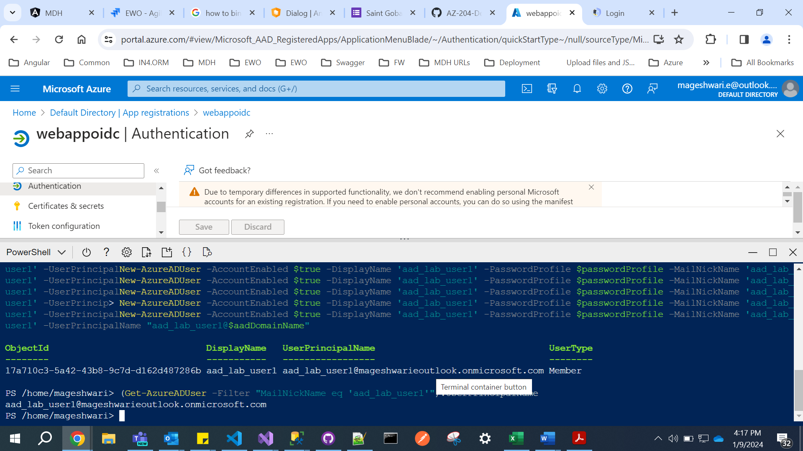

[aad_lab_user1@mageshwarieoutlook.onmicrosoft.com](mailto:aad_lab_user1@mageshwarieoutlook.onmicrosoft.com) : **Pa55w.rd1234**

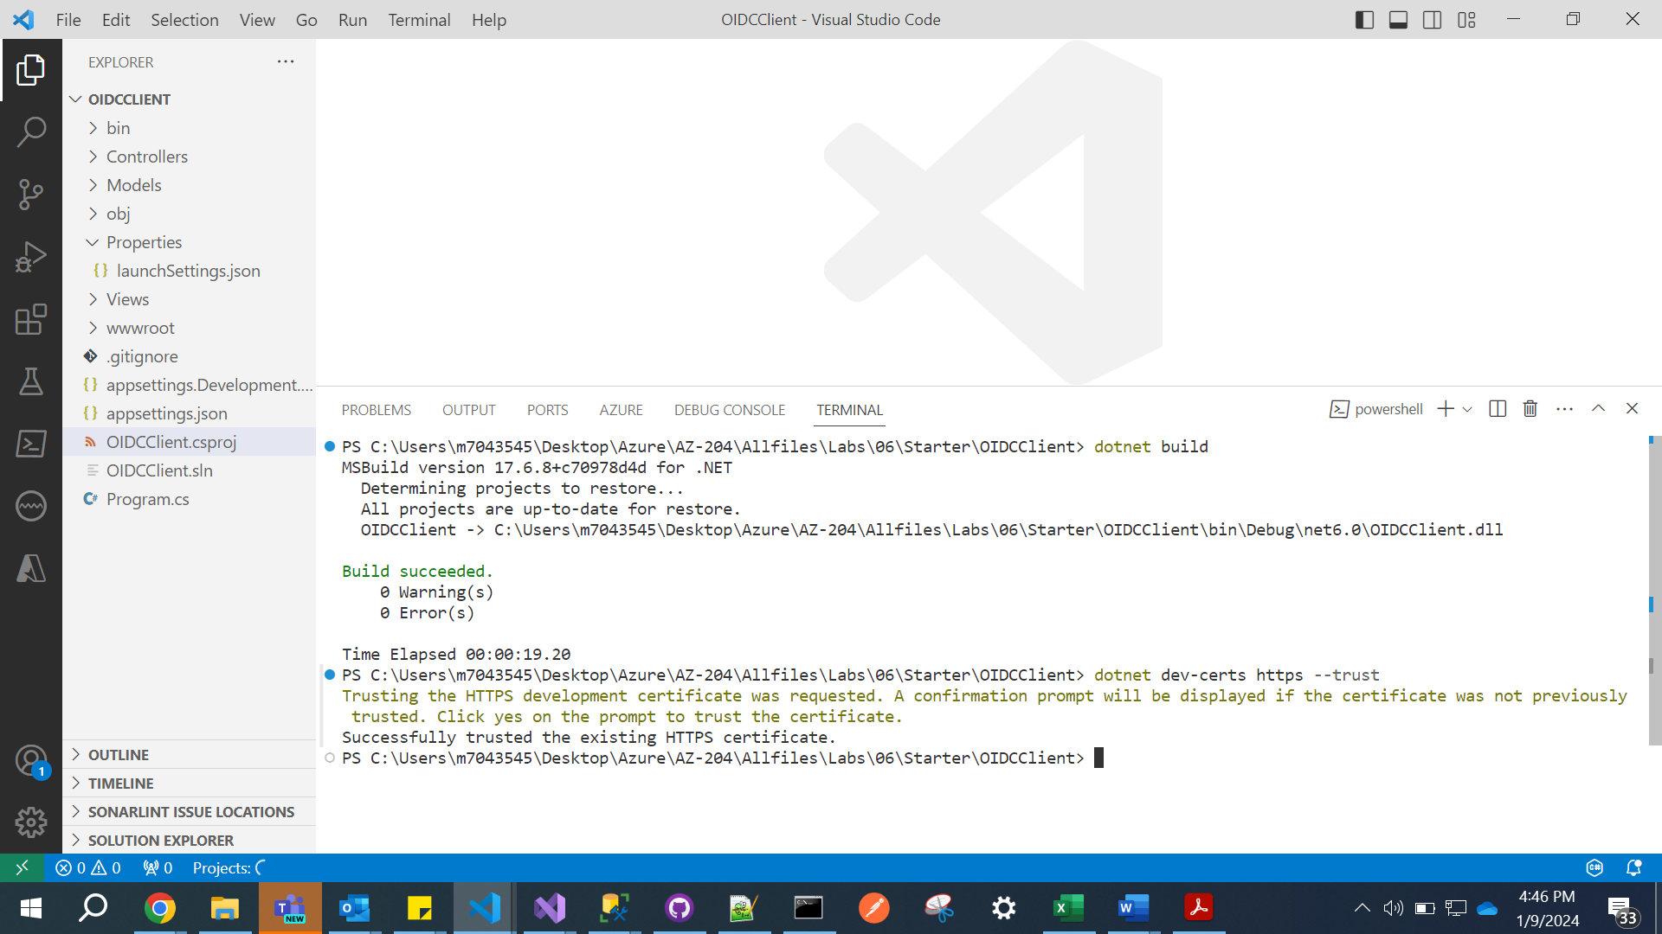

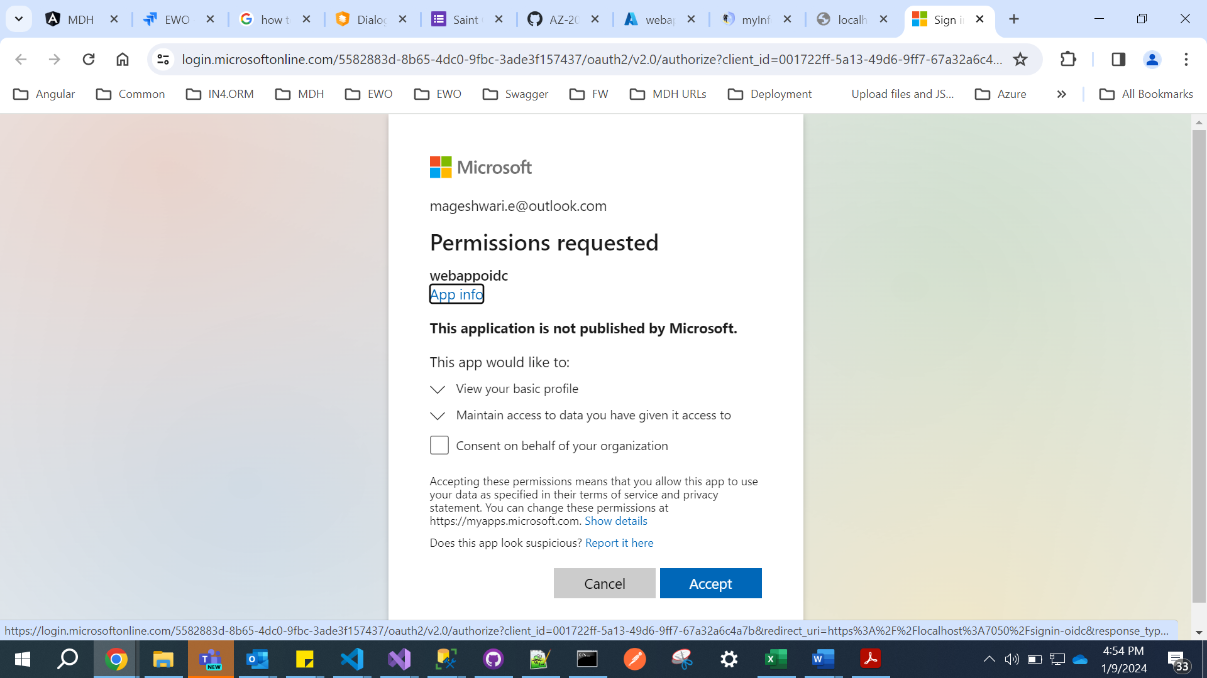

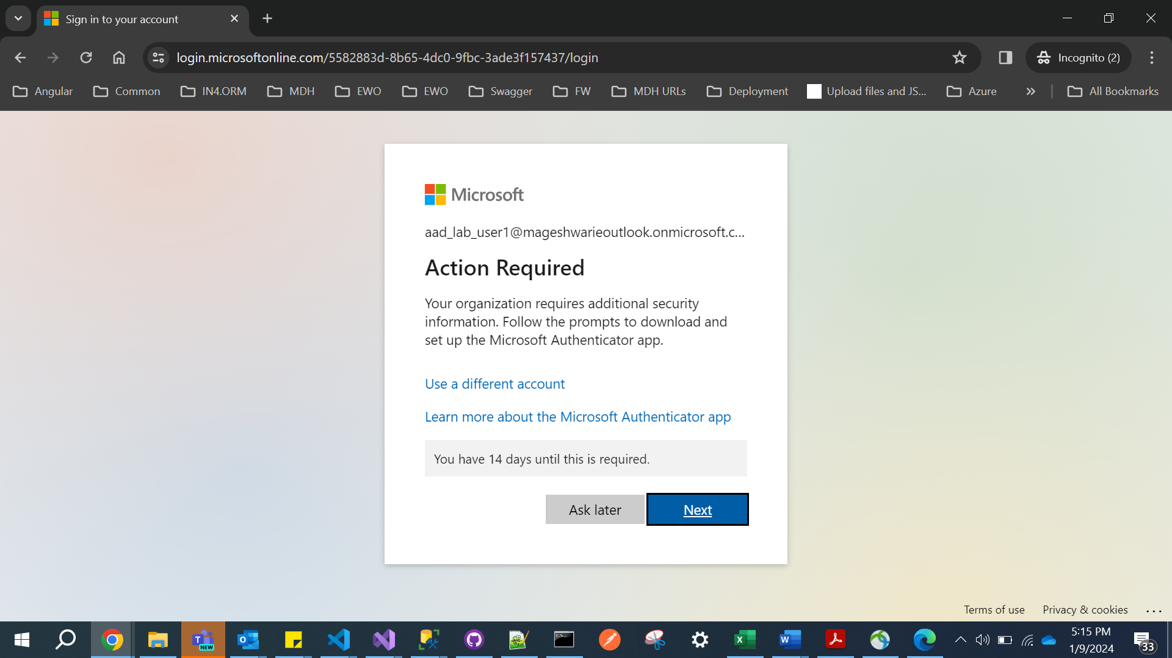

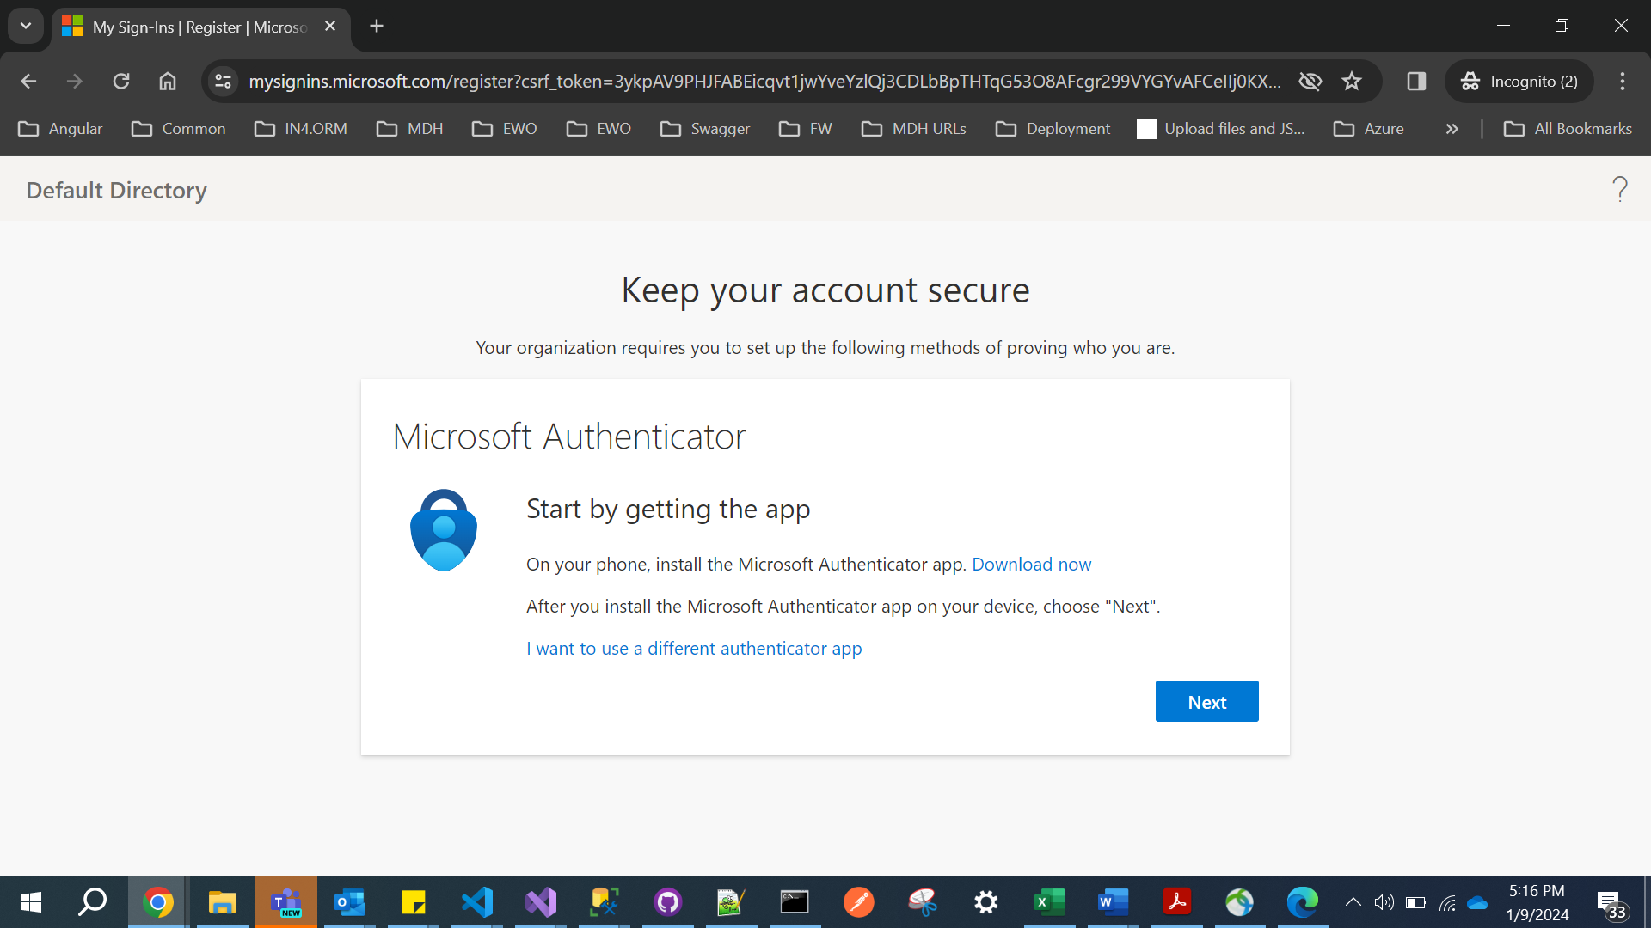

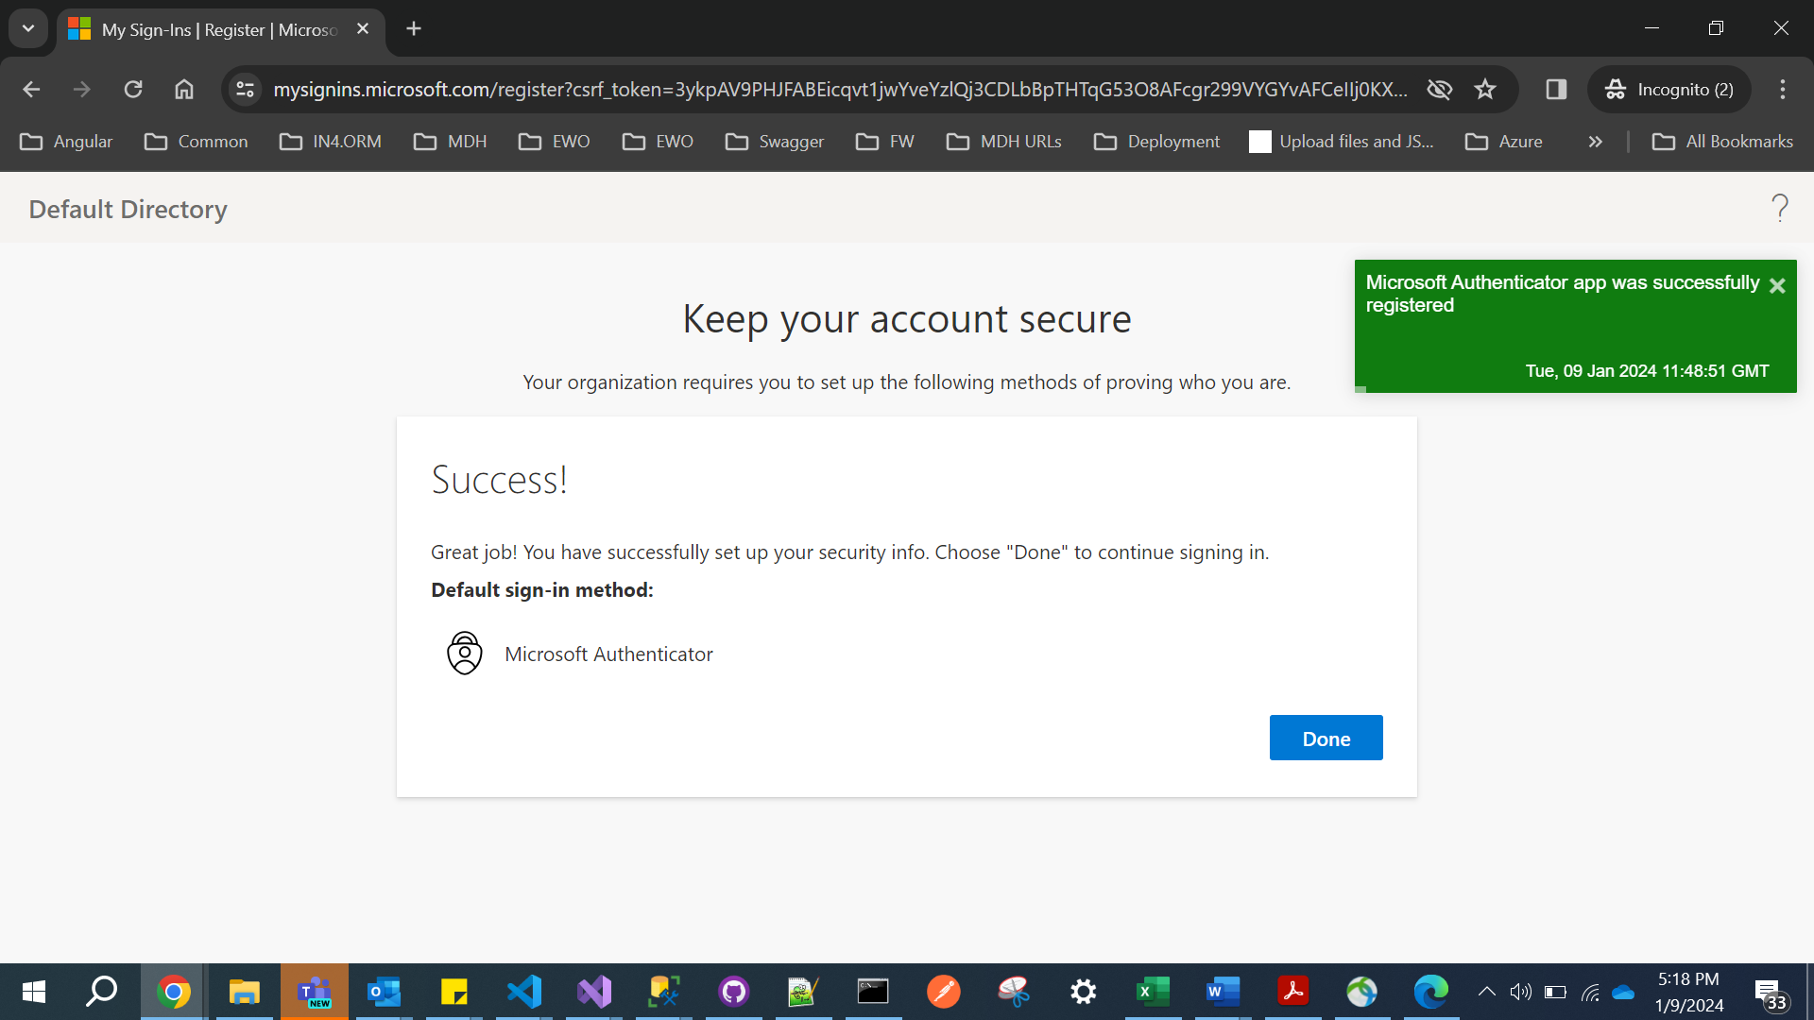

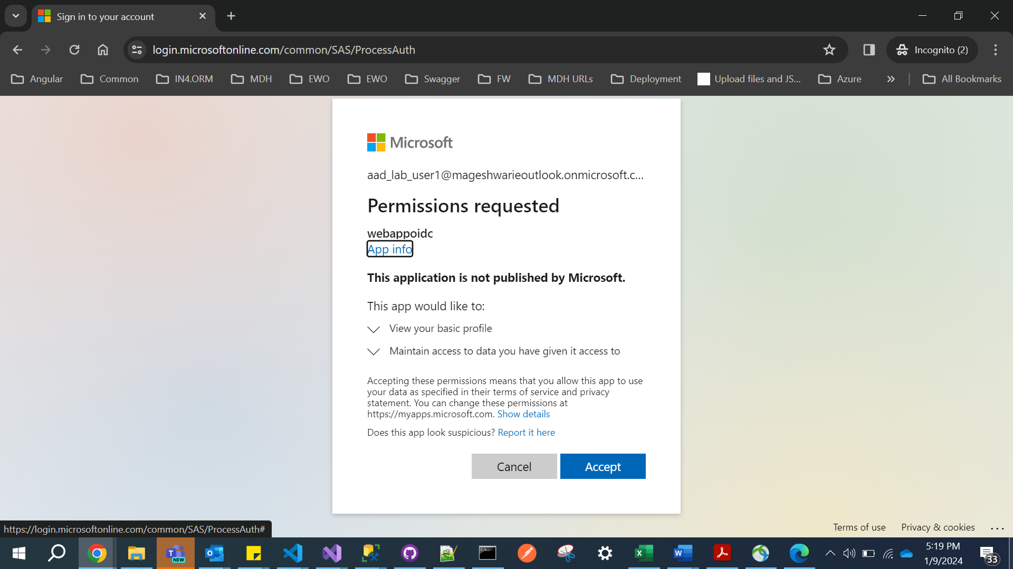

**Lab: Keyvalut**

**DefaultEndpointsProtocol=https;AccountName=securestormageshwari;AccountKey=Ixj3fDgUnA9TwMoCm00rHtqIROH7aYPx9bRPtkK0/xKvz1An4aD5Ci+PKLXZ8LnmPn5LSggOgktx+AStGG31qg==;EndpointSuffix=core.windows.net**

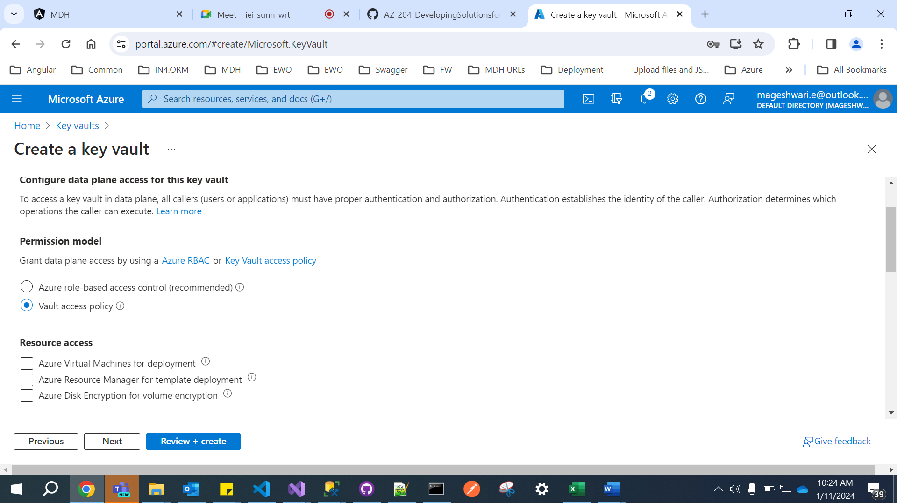

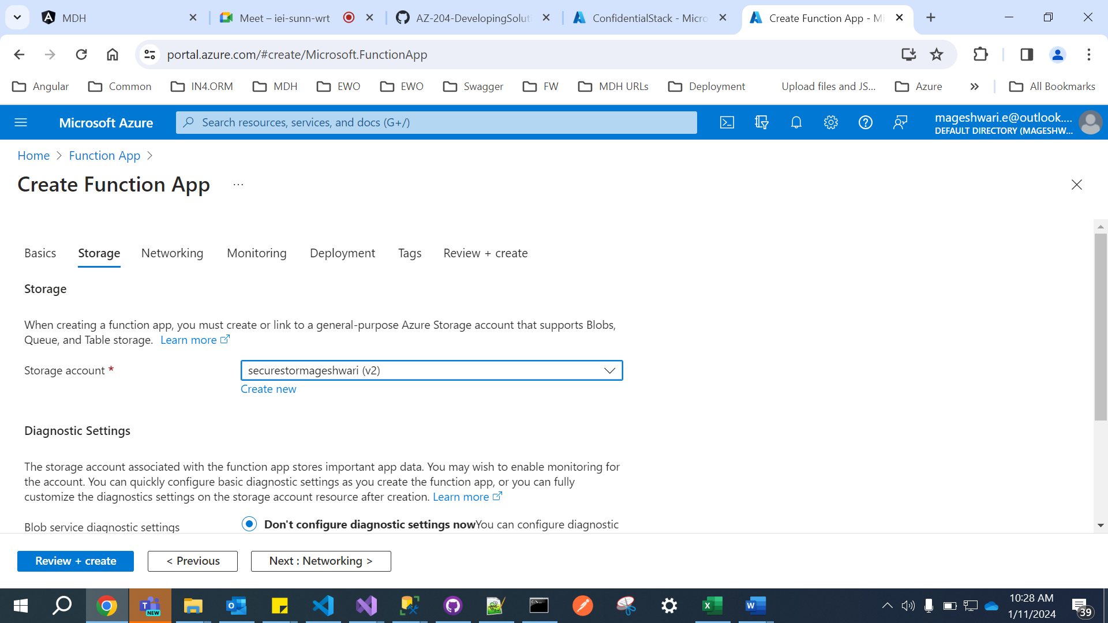

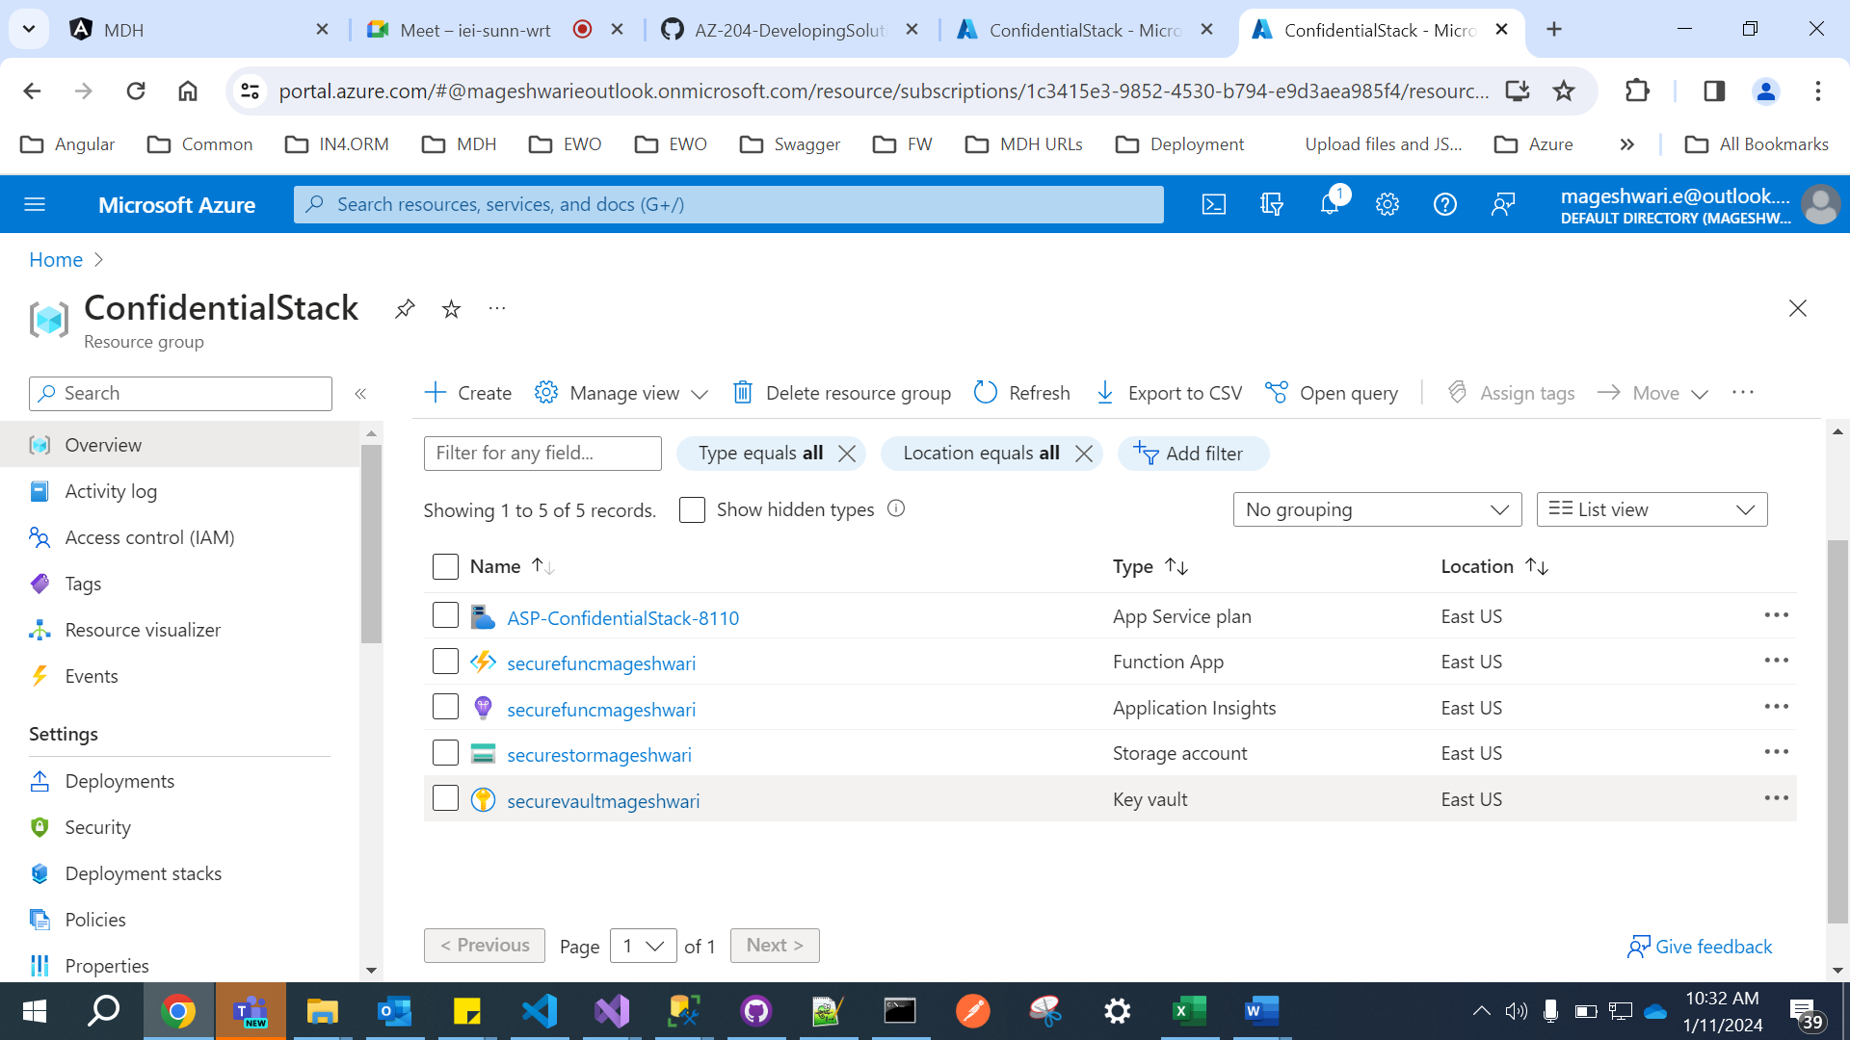

[**https://securevaultmageshwari.vault.azure.net/secrets/storagecredentials/da9b5922969b4a04a1e1c5c7d5828ee4**](https://securevaultmageshwari.vault.azure.net/secrets/storagecredentials/da9b5922969b4a04a1e1c5c7d5828ee4)

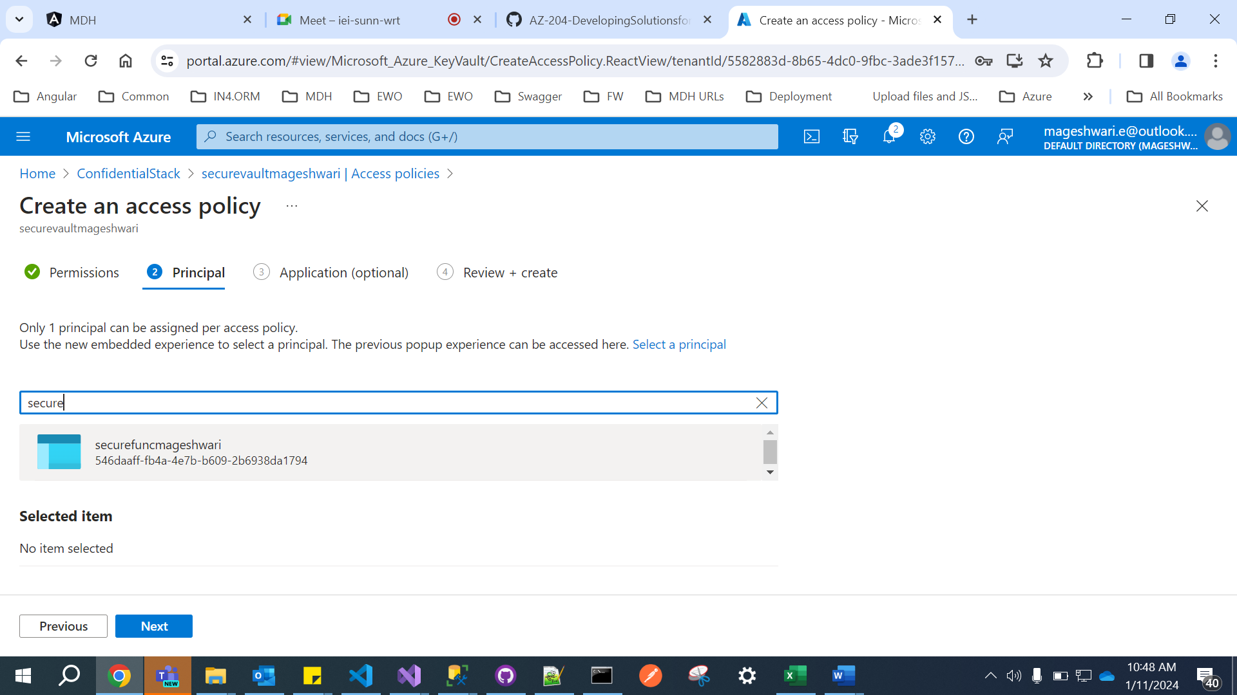

@Microsoft.KeyVault(SecretUri=<Secret Identifier>)

@Microsoft.KeyVault(SecretUri=[**https://securevaultmageshwari.vault.azure.net/secrets/storagecredentials/da9b5922969b4a04a1e1c5c7d5828ee4**](https://securevaultmageshwari.vault.azure.net/secrets/storagecredentials/da9b5922969b4a04a1e1c5c7d5828ee4))

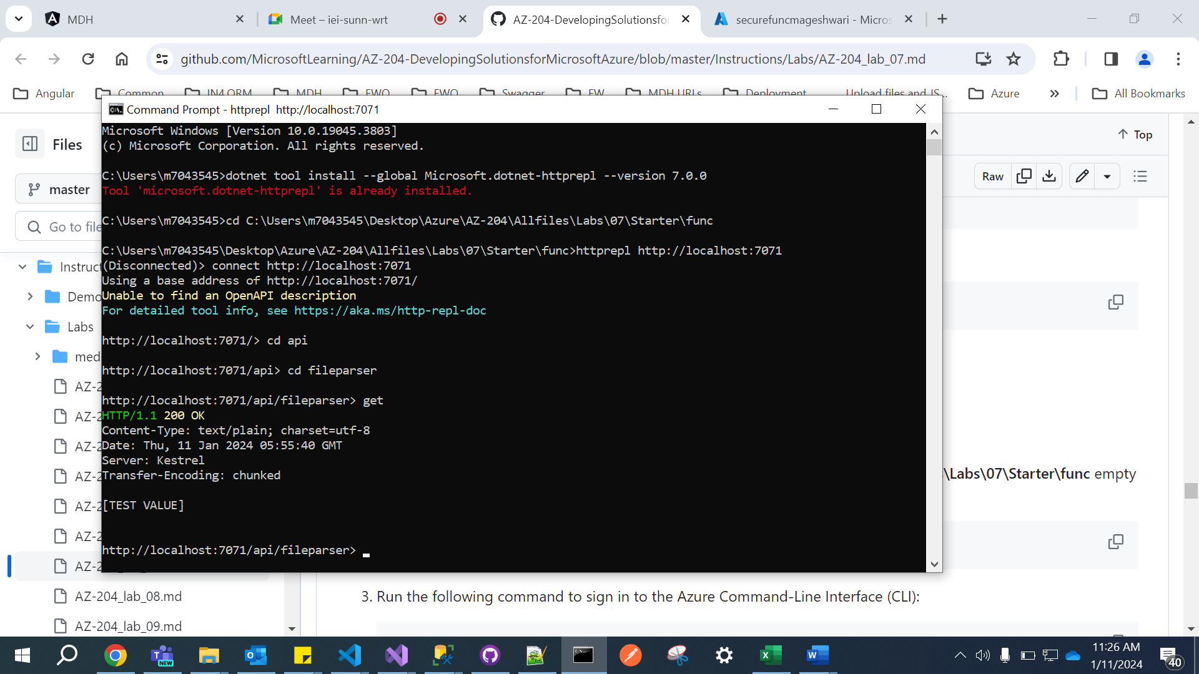

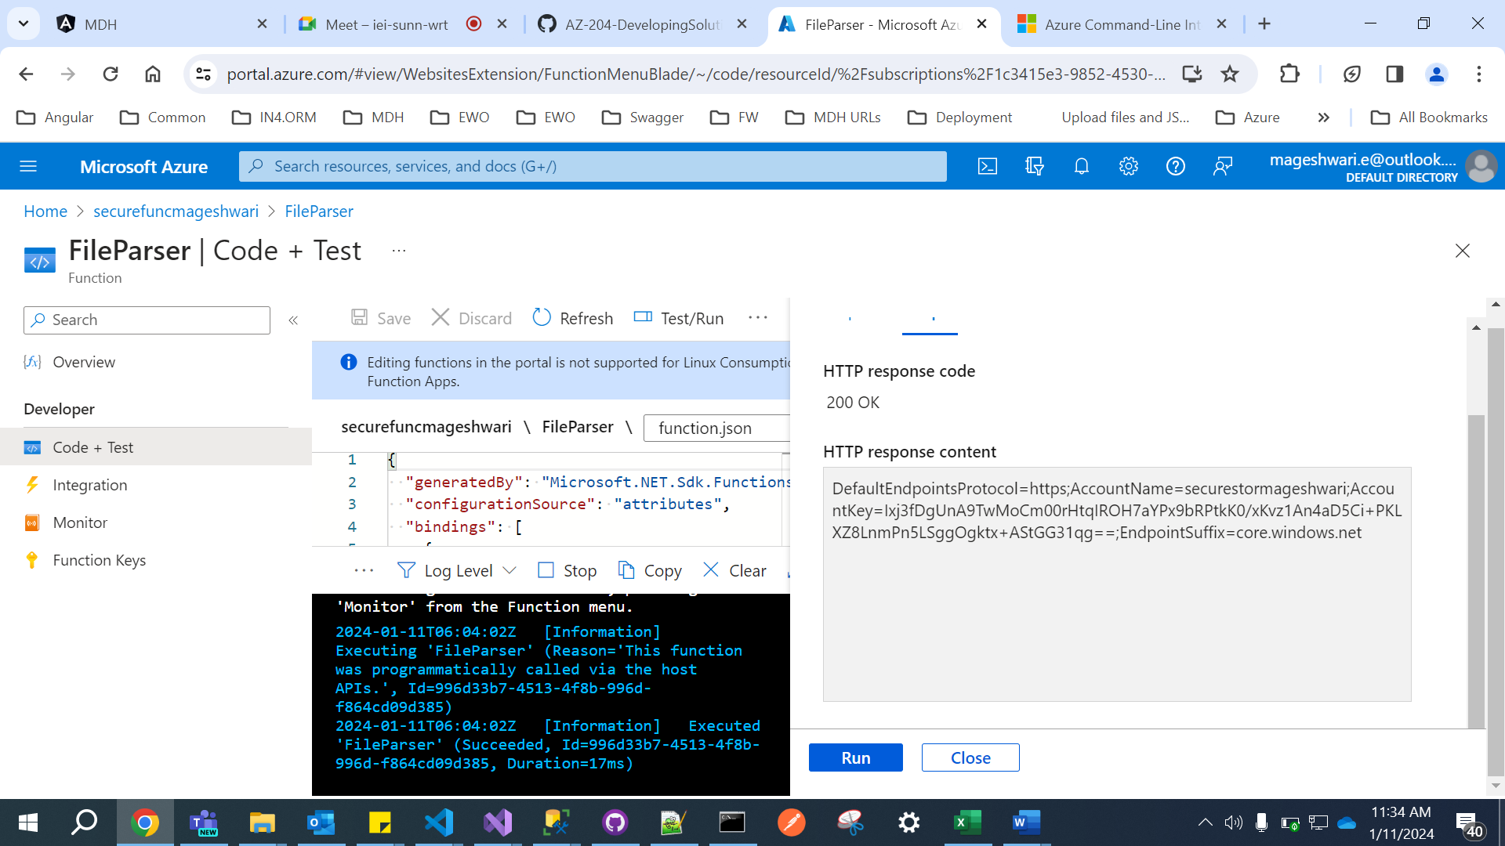

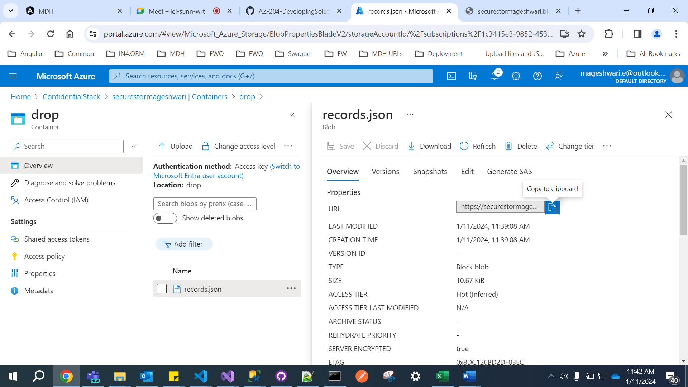

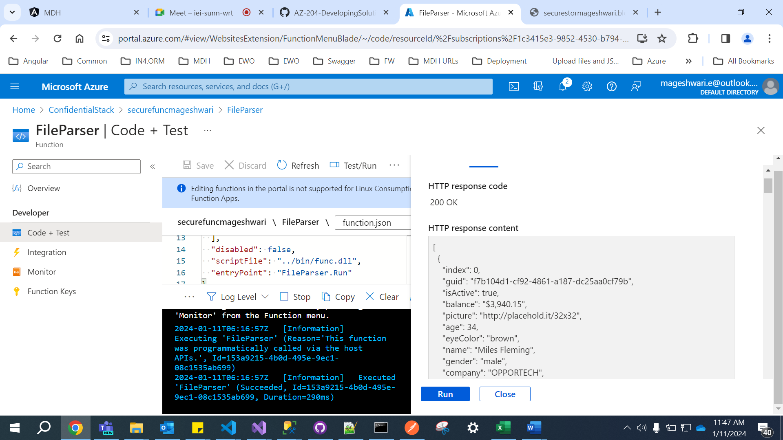

**Kubernates**

**Container Registry :**

1. **Name : Kubermageshwaricr**
2. **Username : kubermageshwaricr**
3. **Password : 456H0FXG+yMm+93lpy3YNOS00hjrkh+FpUBwPgsJN/+ACRBCuXKs**
4. 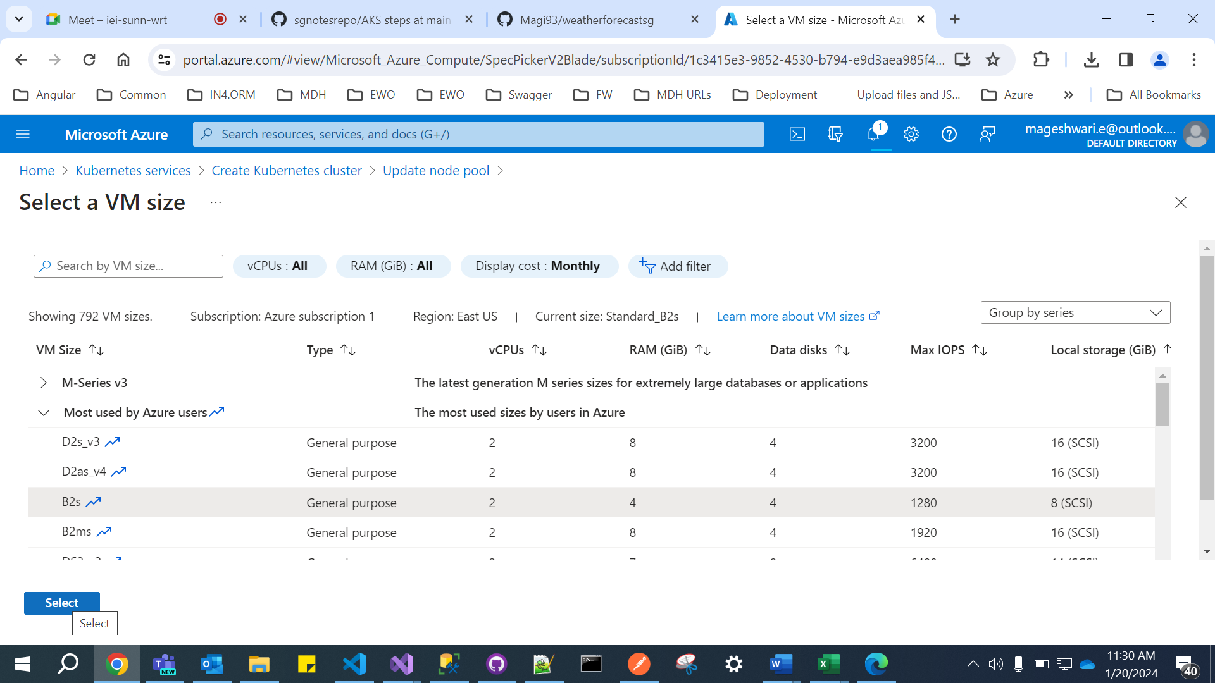
5. 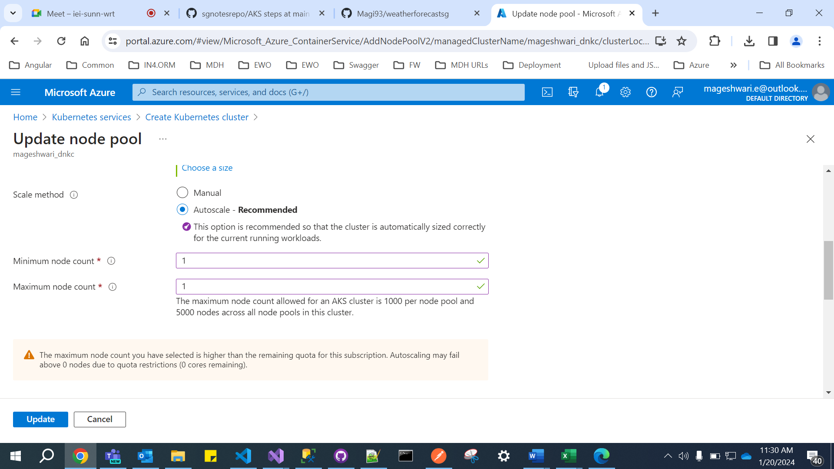

## az aks get-credentials --resource-group SGGroup --name mageshwari_dnkc

## kubectl create secret docker-registry dsconfigsn1 --docker-server=kubermageshwaricr.azurecr.io --docker-username=kubermageshwaricr --docker-password=456H0FXG+yMm+93lpy3YNOS00hjrkh+FpUBwPgsJN/+ACRBCuXKs [--docker-email=Mageshwari.e@outlook.com](mailto:--docker-email=Mageshwari.e@outlook.com)

## 

## 

## 

## 

## 

## 

## 

## 

## 

## 

## 

## 